
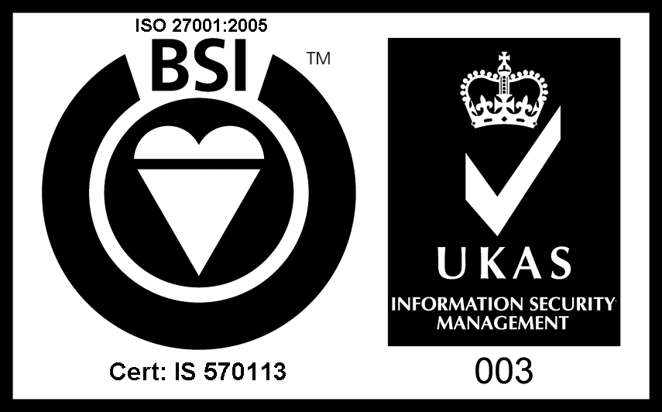


Understanding Society
Immigrant and Ethnic
Minority Boost
(IEMB)
Interviewer instructions
Contents
1. Summary 1
2. Background 7
3. The sample 8
4. Your assignment 8
5. Before you contact the household 13
6. Contacting the household 15
7. Who to interview 28
8. The Electronic Contact Sheet (ECS) 32
9. The interview process 37
10. CAPI interview 38
11. Proxy interviews 41
12. Adult CASI 42
13. Recording contact details 43
14. Collecting details about respondents’ occupations 45
15. The end of the interview 48
16. Translations 51
17. Workpack 59
18. Admin and return of work 60
19. Top Tips for new interviewers 61
Appendix A. Common queries and objections 64
Appendix B. Benefits module details 66
Appendix C. Outcome codes 73
Appendix D. Practice cases and Practice CAPI 78
Appendix E. List of IEMB modules 79
Appendix F. Cultural holidays 2015-16 80
Appendix G - Data confidentiality 82

Summary
Understanding Society is the largest household panel study of its kind in the world.
Understanding Society is an initiative of the Economic and Social Research Council (ESRC), with scientific leadership from the Institute for Social and Economic Research (ISER) at the University of Essex.
TNS BMRB has been commissioned to deliver waves six to eight of the study. As part of wave six of the study we are conducting a new boost of Immigrants and people in Ethnic Minority groups.
This first section is intended to provide an overview of the project and the key processes involved. Full details on each aspect of the study are included in the subsequent chapters of these instructions.

IEMB Sample
The households taking part in the IEMB will all be new to the survey and thus will require ‘starting from scratch’.

This means that for each address you will need to:
- Determine how many dwelling units are at the address and
- Within dwelling unit determine how many households there are then
- Complete the screening at each household to determine whether they are eligible to take part in the study
- Complete the household grid from scratch for all eligible households

Fieldwork
The IEMB fieldwork will be issued in four different batches.

The start dates for each period is as follows:
- Q1 – Saturday 4/4/2015
- Q2 – Tuesday 16/6/2015
- Q3 – Tuesday 25/8/2015
- Q4 – Wednesday 4/11/2015

Overall fieldwork is scheduled as follows:
- 10 weeks original fieldwork
- 2 weeks mop up
- 4 week reissue period (face-to-face only)

All interviewing for the IEMB is to be completed face-to-face.

In advance of contacting the household
Advance mailings are being posted by the office to each address prior to the start of fieldwork.

Response rate targets
In order to ensure that we get a representative sample it is critical that we obtain a high response rate when we conduct the screening. We also need to ensure that we get as many households that are eligible to participate as possible.

We are aiming to:
- Conduct the screening with at least 62% of households
- Interview at least 90% of eligible households
- Interview at least 79% of adults within eligible households that participate

Along with response rate we also want to maximise the number of ‘complete households’ – where all individuals in the household complete an interview.

Dwelling unit and household selection
When you first get to an address you will need to determine how many dwelling units there are there and how many households there are in each dwelling unit. The CAPI script will guide you through the process of selecting the dwelling units and households in which you need to conduct interviews.

We want you to attempt to interview at up to three dwelling units per address, and at up to three households within each dwelling unit.

Full details on this are given in section 6.2.

Screening
Once you have made contact with the selected households you will be required to go through the screening questions with them in order to determine whether or not they are eligible to take part in the study.

Please conduct the screening at EVERY selected household.

Once screened, we only want you to conduct interviews in households where at least ONE household member (including any children or babies):
- Was born outside of the UK, or
- Comes from, or has parents or grandparents from, any of the (non-white) ethnic groups

The CAPI script will guide you through the screener questions and will let you know whether or not a household is screened into the study.

Who to interview within a household
Once households have been screened and found to be eligible you will be required to conduct a household grid to record the composition of the household. Please include ALL members of the household regardless of their age.

All members of the household that are aged 16+ and resident in the household are eligible to be interviewed. The CAPI will determine from the information entered at the household grid which household members you need to conduct an individual interview with. At this wave you will not be required to conduct interviews with members of the household that are currently absent (at halls of residence, boarding school or institutional accommodation).

Note that screening occurs at the household level, but that all adults within eligible households need to be interviewed, regardless of whether they themselves were born outside the UK or are from an ethnic minority group.

SUMMARY
At EVERY screened in Household:
- Include EVERY household member in the grid (regardless of age)
- Conduct an individual interview with EVERY adult aged 16 + (regardless of ethnicity)
NB
If there is only one Household at the sampled address you can conduct the interview using the issued serial number.
If there is more than one Household at the sampled address you can use the serial to interview one household, but you must connect your laptop and wait for the additional serial number(s) to be created before you can do any interviewing at subsequent households.

The ECS
The management of your assignment is done through the Electronic Contact Sheet (ECS). The ECS sits at the beginning of the interviewing script (accessed through screen 0 in the eReps grid). This is where all information about your contact with the address should be entered. The information you record on the ECS needs to be sent back to us electronically at the end of each working day.

You must report a Final Outcome Code for each of the addresses that have been issued to you – whether or not you have actually achieved an interview. A Final Outcome Code should only be completed after you have made ALL your calls at an address. You would, for example, only code a non-contact as a final outcome after you have made a minimum of 5 calls at the address. You would not report a non-contact as a final outcome after your first or second call.

As well as the final outcome codes there are also a number of Interim Outcome Codes you will be using to record the outcome of each visit before the ‘final outcome’ has been achieved. In these cases you will need to continue making calls until a final outcome is achieved. Every call at an address must be recorded with either an interim or a final outcome code depending on which is appropriate.

Please see Appendix C for a list of all the outcome codes relating to the IEMB. Full details on the ECS are provided in Section 8 of these instructions.

The interview process
The data collection instruments are:
- CAPI household grid;
- CAPI household questionnaire;
- Individual Adult CAPI questionnaire for all aged 16+
- Adult CASI (administered as part of the adult CAPI interview); and
- CAPI proxy questionnaire.

The CAPI will guide you through the instruments seamlessly.

You should attempt to get a full individual interview with all eligible respondents. Proxy interviews are acceptable only if you are certain that you cannot get a productive interview.

Help screens
Information about individual questions can be found in the CAPI help screens which you can access by clicking on the links at specific questions.

CAPI interview
The main topic areas covered in the IEMB questionnaire are:
- Personal and family background;
- Ethnicity and religion;
- Languages spoken at home;
- Health;
- Relationships;
- Migration history and fertility history;
- Employment;
- Childcare; and
- Finances.

Differences to the main stage
For those of you that have worked/are working on the main stage of the Understanding Society study, the IEMB differs in the following ways:
- The IEMB consists of completely fresh sample only and is being conducted fully face-to-face (i.e. no web or telephone interviews)
- Each issued address can split into up to three dwelling unit(s) and each dwelling unit can split into up to three household(s). You will need to determine this.
- Only one advance mailing has been sent to each address and it does not include an incentive or a change of address card
- There is a screener to be completed with all selected households to determine eligibility
- When completing the household grid we DO want you to include those that are members of the household but currently absent as household members
- The individual questionnaire has slightly different content to the main study and has an average length of 30 minutes
- Incentives are all to be given at the end of the individual interview
- There is no youth self-completion questionnaire
- There are no questions or forms regarding consent to data linkage
- Outcome codes are consistent with the main stage where possible, but because the IEMB covers fresh addresses and includes screening the list is quite different

Queries
If in doubt, please contact your RFC or the CAPI Helpdesk (0800 015 2103) as appropriate.

Background

Ethnic minority boost at Wave 1 of Understanding Society
At wave one of Understanding Society there was an ethnic minority boost (EMB1). This consisted of over-sampling of five key ethnic groups:
- Indian
- Pakistani
- Bangladeshi
- Caribbean
- Black African.

There is a need to boost the numbers of interviews with these groups due to:
- Increasing prominence of research into ethnic difference for understanding the make-up of UK society
- Focus on issues of diversity and commonality

The new Immigrant and Ethnic Minority Boost
As part of the second year of wave 6, we are conducting a new Immigrant and Ethnic Minority Boost. This is designed to be more inclusive than original ethnic minority boost as it includes all immigrants and all ethnic minority groups.

Why do we need another boost?
- To increase numbers of immigrants and members of ethnic minority groups available for research
- Analysing the two boosts together (IEMB & EMB1) will provide 87% coverage of ethnic minority groups and 74% coverage of immigrant groups in the UK
- The IEMB will be analysed in combination with the EMB1 and this will allow comparisons to also be made with the wider general population
- The new boost will allow comparison of new immigrant communities with more established communities
- To keep the sample representative of the current population (i.e. to capture any new immigrants that have come to the UK since the start of wave 1)

The sample
The sample for the IEMB is comprised solely of new addresses selected at random (from the Postcode Address File). The sample was selected from random postcode districts amongst those with moderate to high ethnic minority or immigrant population density. The aim of the study is to obtain a nationally representative sample of people in immigrant and ethnic minority groups. Northern Ireland is excluded due to having very few immigrants or people in ethnic minority groups.

We don’t know who is living at each address, so when you receive your assignment it will just be addresses. We take addresses from the most recent PAF but be aware that addresses may be slightly out of date: the address may have been demolished and also sometimes house building companies put new house addresses onto PAF before they are even built. Once an address has been selected it CANNOT be substituted with another address.

Your assignment
Assignments will vary in size but the average number of addresses will be 36. Over the year assignment sizes will vary from 13 addresses to 120. The number of addresses is not a good guide of how long it will take you to cover your assignment. Some assignments will have a high number of addresses–requiring you to spend lots of time screening and not so much time conducting interviews. Whereas other assignments will have a smaller number of addresses where most households will be eligible and you will spend most of your time interviewing rather than screening. For those of you that have worked on the main stage it is worth noting that IEMB addresses are also more tightly clustered than main stage assignments.

As the make-up of each assignment varies you will be provided with additional information so that you have an idea as to how many households are likely to be screened in to the study. You will receive a sheet for each assignment (labelled “Your IEMB assignment”) which has the following details:
- Number of addresses in your assignment
- Number of households we expect to screen in

Please note that this information is based on the 2011 Census so whilst it will give you a good idea of what you are likely to find in the area it will not match completely. Also note that this is intended as a guide only and you should continue to contact all issued addresses and interview all of the households screened in until your assignment is complete.

Figure 4.1 Example copy of the “Your IEMB assignment” sheet
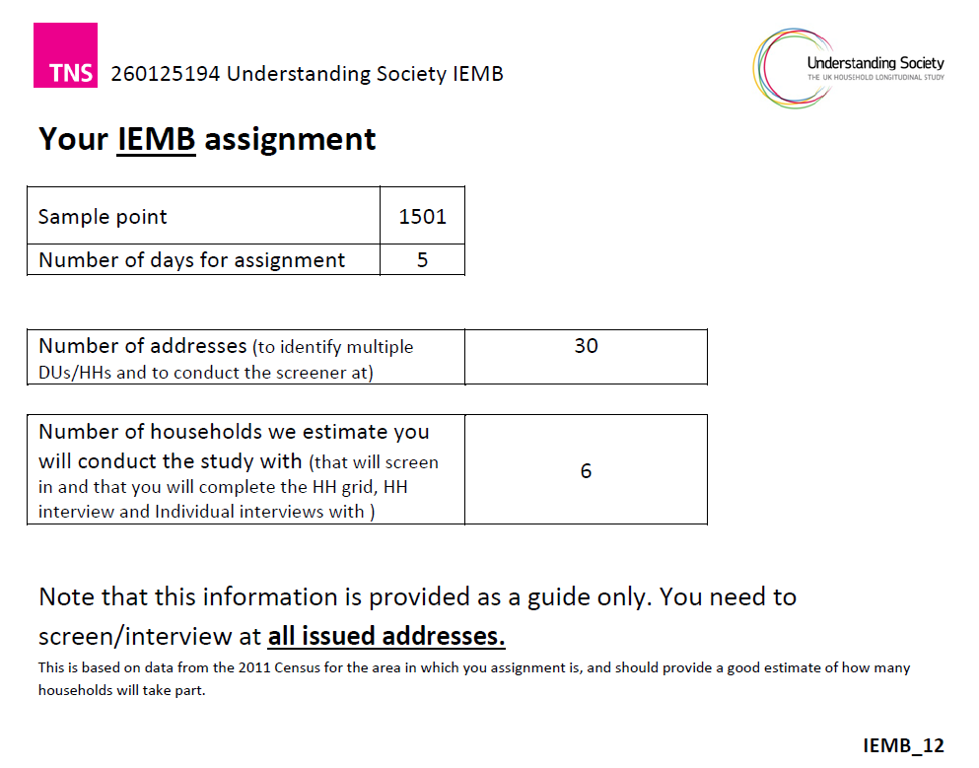

You will be required to call at each of these addresses and conduct the screening to determine whether or not households are eligible to take part in the study. For eligible households you will need to conduct the household grid, household interview and individual interviews with all household members aged 16+.

Fieldwork period
There is an initial 10 week fieldwork period for the IEMB followed by a 2 week mop up period and 4 weeks of reissues.

Fieldwork milestones
Your targets for coverage during the fieldwork period are:

End of Week 3:
Make first call to ALL serials
Completed the screening at 50% of serials

End of Week 6:
Completed the screening at ALL serials
Fully covered 40% of eligible households (excl. No Contacts)

End of Week 8:
FULLY covered 90% of eligible households (exclude No Contacts)

End of Week 10:
FULLY covered 100% of eligible households

If you have an assignment with a very high number of addresses to screen, you may be allowed extra time to do the screening. You will be informed by your RFC if this applies to you.

Individuals and households
Understanding Society is a survey of individuals in their household context. This means that where a household is screened into the study we want you to interview all adults within the household regardless of whether they themselves are an immigrant or an ethnic minority.

Therefore it is very important that as far as possible we obtain FULLY productive households – where ALL eligible individuals are interviewed. This may require you to make multiple visits to households in order to interview all eligible individuals.

Response rate targets
In order to ensure that the sample is representative of the population it is critical that we obtain as high a response rate as possible.

Our key response rate targets for the survey are:
- Find on average 33% non-deadwood households will be eligible
- At least 62% of households screened for eligibility
- At least 90% household response rate among eligible households
- At least 79% adults (aged 16+) interviewed in productive households
- Find an average of 2.29 adults per household

For a household to count as productive, at least one full adult interview must be been completed.

A fully productive household is where the grid, household questionnaire, and all eligible adult interviews have been completed in full (not proxy interviews).

Proxy interviews do not count towards the adult interview rate.

Interviewing in different communities
As when conducting all fieldwork, you should be ‘clean and tidy’ and dressed appropriately for the neighbourhood in which you are working.

In certain households difficulties may sometimes arise because your gender differs from that of a respondent. This can happen whether your cultural background is the same or different. Do not assume there will be a problem, individuals within any culture or of any faith may differ greatly in what they find comfortable and acceptable within the interview situation.

There are some important points to consider:
- In some communities female respondents may not want to be alone with a male interviewer, they may want another family member to be present
- Women may prefer to have a relative with them during the interview; this may be either a male or another female (adult or child)
- Men may be reluctant to speak to a woman they do not know if this is not usual in their culture.
- If necessary contact your RFC and the serial can be reallocated
- Certain days and times are not appropriate for certain religions groups:
  - Jewish communities: Friday afternoons and Saturday
  - Islamic communities: Friday afternoons
  - Pay attention to when there are religious festivals and faith holidays - for example Passover, Eid, Ramadan or Diwali. Please see Appendix F for dates of some principal cultural holidays in the UK during 2015-16 fieldwork.

Some questions or topics may be less acceptable (or even considered offensive) in some communities or cultures. Problems may arise in some contexts in asking questions on other topics such as health or relationships.

It is important that these questions are still asked but you must do so sensitively and be ready to explain that in a survey they need to be asked of everyone. You may also explain that every respondent has the right not to answer a question if they are unhappy to do so.

Before you contact the household

Planning your assignment
The addresses in your assignment are clustered across a large area, so it is important that you plan ahead and organise your addresses into a logical order before you start interviewing.

Notify the police
If you are working on an original issue assignment you must notify the police before you start working in your area. Hand in a copy of the Police Form and a copy of the generic advance letter. You should make a note of the name and number of the person you spoke to and ask them, if possible, to rubber-stamp your copy of the Police Form and sign it with their name. This will give you some proof of having notified the police.
You will need to record the name of the police station in the ECS. It is not essential to notify the police if you are working on a re-issue assignment.

If the police would like further information about the study, they may contact the Understanding Society team (at the University of Essex) using the freephone number 0800 252 853.

Advance mailing
Sampled addresses will be sent an advance mailing in the week before fieldwork starts. This card lets them know that an interviewer will visit them soon to ask a few questions and that the interviewer may ask those aged 16 or more in their household to take part. The letters are despatched centrally by the Office.

As the IEMB is made up of fresh sample and we do not know the composition of households we will be sending only one advance card per address.

An image of the advance card is shown overleaf.

Figure 5.1 Advance card example
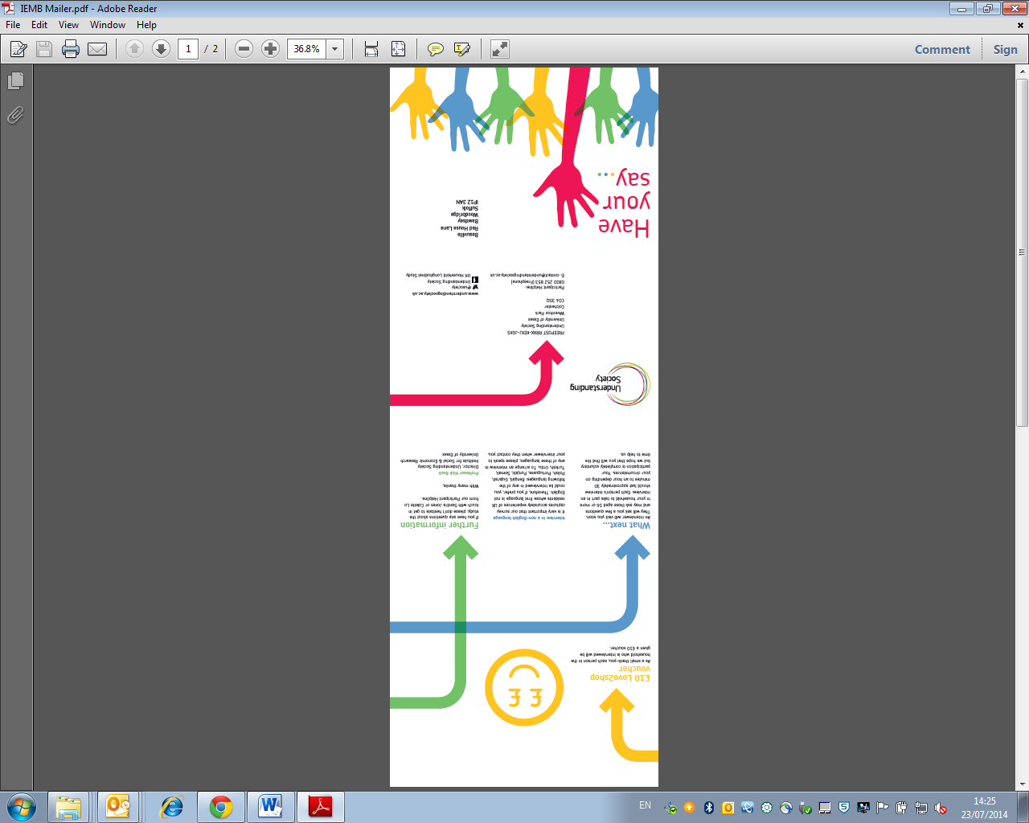 | 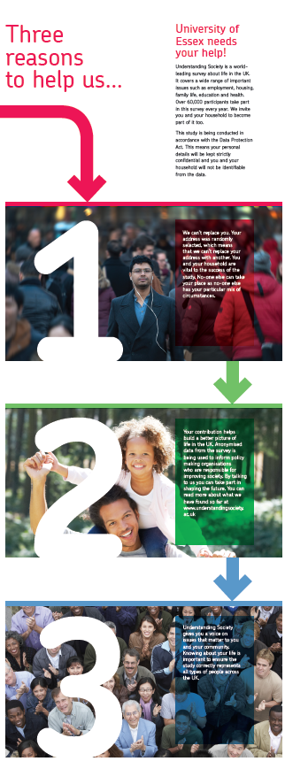

Contacting the household

Call patterns
The minimum call requirements before coding a final ‘no contact’ outcome are:
- At least 5 face-to-face visits to the address, on different days;
- These must include at least 3 visits on a weekday evening (after 7pm) or at the weekend (at least one on a weekday evening, and one at the weekend)
- Calls must be made over a period of at least 2 weeks

Once you have made contact with a household and conducted the screening you should make all possible efforts to ensure that you conduct interviews with all eligible respondents.

Research shows that:
- The more you vary the times of day you call, the fewer calls you will have to make and you will get a higher response rate;
- Leaving a few days between calls will produce a higher contact rate, you will have to make fewer calls and you will get a higher response rate.

So, it is important that you stick to the TNS BMRB call pattern rules and start work right at the beginning of the fieldwork period so that you can spread out your calls more.

If no one is at home, leave an Understanding Society IEMB interviewer card (see overleaf) to inform the residents of your visit. You may use the study Freephone number (0800 195 6452) as a contact number for respondents. This number is staffed 9am – 5pm Monday to Thursday and 9am – 4pm on Fridays. Outside these hours, an answer phone service operates.

Figure 6.1 Interviewer card


Note that this card is slightly different to the card being used for the main stage of Understanding Society – it has a different Freephone number – so if you are working on both parts of the study please make sure that you do not mix these up. The IEMB card has “IEMB 6” written in the bottom left hand corner of the blank side.

Upon making contact, always remember to show your ID, even if the people you speak to do not appear to be interested in it. If sample members have any queries which you cannot answer at your initial face-to-face visit, ask them to call the Understanding Society team on Freephone 0800 252 853. Please not that this number is an information line for respondents only which goes through to staff at the University of Essex.

Dwelling unit and household selection
Dwelling units
When you first get to an address you will need to determine how many dwelling units there are there and how many households there are in each dwelling unit.

A Dwelling Unit (DU) is a living space with its own front door – this can be either a street door or a door within a house or block of flats. Usually there is only one dwelling unit at an address.

The usual process for dealing with multiple dwelling units at an address is for one to be selected at random (through ECS). For the IEMB the procedure differs; we want to attempt to interview at up to three dwelling units per address.

Start by making contact with someone at the address to find out how many dwelling units there are. Once you have ascertained how many dwelling units there are there are three possible scenarios:

If there is only one dwelling unit then it is simple
- You just attempt to do the screening there

If there are two or three dwelling units
- You need to enter a unique description of each DU (e.g. flat number) into CAPI
- You can use the serial you currently have to do the interviewing at one of these DUs
- You will need to communicate your CAPI machine and then wait 2-3 working days until you are issued with additional serials for the other DU(s)

If there are four or more dwelling units
- You need to enter a unique description of each DU (e.g. flat number) into CAPI
- The CAPI will randomly select three DUs for you to screen
- You can use the serial you currently have to do the interviewing at one of these DUs
- You will need to communicate your CAPI machine and then wait 2-3 working days until you are issued with additional serials for the other DU(s)

For addresses with more than one dwelling unit, the information in the Erep grid will be updated so that you can identify which serial is for which dwelling unit. In particular:
- The address line will be updated to show the unique description which you entered into the script
- You can hover over the postcode to see the full address
- You can go into “Open all call history” to see further details
- When you go into screen zero after the DU has been selected a screen will appear also confirming which DU this serial is for

Households
The same process applies for households within dwelling units, where we want you to attempt to interview up to three households within each dwelling unit. The ECS will again take care of the random selection, but if there is more than one household you will need to wait until you have been issued additional serials before you can conduct any interviewing there.

A household is when one person or a group of people have the accommodation as their only or main residence and share at least one meal a day or share the living accommodation.

Around 95% of addresses will only have one DU and one household - multiple DUs/households tend to be concentrated in urban areas, so it is likely that either your assignment will contain no multiple DUs/households or you will have several in an assignment.

The CAPI script will guide you through where you need to conduct interviews and additional serials will be issued to you where you need to conduct interviews at additional dwelling units or households. Please ensure that you connect at the end of every day so that we know when you need new serials.

If you are expecting a new serial number but have not received it after 3 working days please contact your RFC.

Introducing the study
The ECS includes our suggested introduction to the study:
Good afternoon/evening. My name is [NAME] (SHOW ID CARD). I'm working on the Understanding Society study for the University of Essex.

We recently sent a letter to this address about the study so I hope you were expecting my call.

IF NECESSARY:
The study covers important subjects such as your health, your neighbourhood, your opinions, your family and your job, and will create a lasting record of who we are and what we believe.

The information collected can inform Government policy and is used by academics, policy-makers and researchers working for charities and the voluntary sector in this country and abroad.

As all IEMB respondents will be new to the study you can use the ‘All you need to know about Understanding Society’ leaflet on the doorstep to provide them with some information about the study.

We would also like you to use your expertise when introducing the study and highlight different areas of the study accordingly. Below are some of the research questions that this study addresses and that you may find helpful when encouraging people to take part:
- How people’s well-being changes over time;
- The effects of poor health on employment opportunities;
- Whether or not our education system provides the springboard for young people to develop their careers;
- Whether retired people are managing on their pensions;
- Whether disabled people are getting the care they need;
- The effect of the economic down-turn on different aspects of life;
- How family life is changing and what people think about these changes.

When you make contact at the address you will need to explain that you are seeking interviews with particular groups of people.

If people want to know why we are screening you can explain that we need to do this in order to have a large enough number of interviews with immigrants and people from different ethnic backgrounds as selecting addresses at random will not provide sufficient numbers for analysis.

Introducing the survey to those that do not speak English:
If the person that answers the door does not speak English, please ask to speak to someone in the household that does speak English in order introduce the study and to complete the screener questionnaire.

You have been provided with a translation card for the IEMB which you can use to identify which language the person at the doorstep speaks. On the back of the card it says “Does anyone who lives in this household speak English?” in multiple languages. An interviewer who worked on the first ethnic boost recommends saying “English”, and pointing at your wrist or watch, and hopefully you’ll get a sign of what time someone who speaks English might be at home for you to talk to. If no-one in the household speaks English then you need to ascertain which language they do speak and code the appropriate outcome for the HH. If they speak one of the nine official IEMB languages someone who can speak the language will go back to conduct the interview with them. Full details on the approach for translations in the IEMB are given in Section 11.

Screening households for eligibility
When you have made contact at a household you will be required to conduct a short screener questionnaire to determine whether the household is eligible to participate in the IEMB. The CAPI script will guide you through the screening questionnaire and will determine whether or not households are eligible.

There are two questions used to determine whether the household is eligible. You have been provided with a screener card which you should use at this point.

Q1 Is there anyone living at this address who was born outside the UK, including children?

If the answer to this question is “Yes” then the household is screened in to the study, if the answer is “No” or the person is unsure there is a second question.

Q2 Does anyone living at this address come from any of the following ethnic groups, or have parents or grandparents from any of these groups, including children?

The following groups are listed on the screener card:
- None of these
- Indian
- Mixed Indian – (parents or grandparents from Indian ethnic group AND parents or grandparents from a non-Indian group)
- Pakistani
- Bangladeshi
- Sri Lankan
- Caribbean/West Indian
- Mixed Caribbean/West Indian (parents or grandparents from Caribbean/West Indian ethnic group AND parents or grandparents from a non-Caribbean/West Indian ethnic group)
- North African
- Black African
- African Asian
- Chinese
- Far Eastern (includes Filipino, Thai, Malaysian, Japanese, Vietnamese, Singaporean, Indonesian, Korean, Burmese)
- Turkish
- Middle Eastern/Iranian (includes Israeli, Palestinian, Lebanese, Syrian, Jordanian, Yemeni, Saudi, Iraqi, Afghani, other Gulf states)

If any member of the household (or one of their parents or grandparents) is from one of these ethnic groups then the whole household is screened into the study. Please note that this also applies to any children that live in the household.

For households that are screened into the study, you should attempt to complete a household grid, household questionnaire and individual interview with all those aged 16 or more.

Households where all members were born in the UK and none of the household members (or their parents / grandparents) come from any of the listed ethnic groups are screened out of the study.

If the household is not eligible you should thank the respondent for their time and explain that today you were only looking for households with immigrants or people from non-white groups so we do not need to include them in the survey. Some people may be disappointed that they cannot take part in the survey. You should explain to people that, while the main part of the study includes everyone whose address is selected, we also need extra interviews with people who are immigrants/ or from ethnic minority groups. This is because the main part of the study will not provide enough people in immigrant and non-white groups for statistical analysis. Carrying out these extra interviews means that we have enough people for the survey to be representative of different ethnic/immigrant groups.

Three possible outcomes from the screening:
1 - Screened in
If any member of the household (or one of their parents or grandparents) is from one of these ethnic groups then the whole household is screened into the study. Please note that this also applies to any children that live in the household.

For households that are screened into the study, you should attempt to complete a household grid, household questionnaire and individual interview with all those aged 16 or more.

2 - Screened out
Households where all members were born in the UK and none of the household members (or their parents / grandparents) come from any of the listed ethnic groups are screened out of the study.

There is nothing further that you need to do, you should thank the respondent for their time and explain that today you were only looking for households with immigrants or people from non-white groups so we do not need to include them in the survey. Some people may be disappointed that they cannot take part in the survey. You should explain to people that, while the main part of the study includes everyone whose address is selected, we also need extra interviews with people who are immigrants/ or from ethnic minority groups. This is because the main part of the study will not provide enough people in immigrant and non-white groups for statistical analysis. Carrying out these extra interviews means that we have enough people for the survey to be representative of different ethnic/immigrant groups.

3 - Uncertain eligibility
If you have been unable to make contact with a household or if the person you speak with at the household is unable to give an answer to the screener questions then we are uncertain as to whether the household qualifies for the study or not.

You should come back to the household to complete the screener questions again at a different time/with a different person to determine eligibility.

Subsequent contact with household
After you have made your first contact in person, subsequent contact can be made by telephone if the household are happy for you to call them, e.g. to arrange or check appointment times. However, you must not carry out interviews by telephone.

There is a section of the ECS which allows you to enter a contact name and telephone number for households, so please try and record this information where possible as it will make your task easier if you need to make contact with the household again at a later date. Once you have entered these details they will be displayed at the top of the screen in the ECS.

Furthermore, once you have completed an individual interview with a respondent you will also be able to access the telephone number you entered for them in the Contact Details module. You can do this by selecting the screen of the individual in eReps and pressing the “Open all Call History” button, the number will be displayed in the “Respondent Phone No” field. This number may be of use in contacting the household to arrange interviews with the other members.

Maximising response
There are three main ways to maximise response rates:
  - Identify deadwood correctly
  - Maximise contact with people at your addresses
  - Maximise co-operation (i.e. avoid refusal)

Deadwood
Although the addresses are selected from PAF this doesn’t tell us if the addresses are residential or if anyone is living there, furthermore PAF may be slightly out of date. So you need to determine for each address if it is ‘traceable, residential and occupied’ - in other words if it is the only or main address of a private household. In an average assignment, we would expect 8%-10% of addresses, on average, to be deadwood (e.g. student halls, care homes, shops, factories).

If you are in any doubt always check at an address e.g. to identify any private households living in business premises (which would be eligible).

The most important type of deadwood to identify correctly is vacant properties:
  - it is the most common (approx. half of all deadwood is vacant property)
  - it is often the most difficult to establish
You will need to ask at neighbouring addresses to try and find out whether anyone actually lives in the address. If you are in doubt you cannot code this as deadwood, it should be coded as a non-contact.

It is critical to identify deadwood correctly - as these addresses are ineligible and therefore excluded from response rate calculations.

Maximising contact
To maximise your chances of making contact start making your visits early in the fieldwork period of your assignment. This will give you more time to make call backs, find people in and determine if there are multiple dwelling units and / or multiple households at each address.

Follow the call pattern rules set out in Section 6.1 of these instructions.

Maximising co-operation
It is important that you prepare answers to potential questions so that on the doorstep you are able to tailor your response depending on the issues raised and who you are talking to. A list of objections and our suggestions as to how you can counter them has been included in Appendix A.

You need to try and avoid refusals where possible. Don’t rush people; allow them plenty of time to look at the advance mailing, at your ID and to check you are genuine. Remember that a friendly approach works best. Withdraw if it’s not a good time and a refusal is likely and come back at a different time.

Focus first on completing the screening – there is just a short set of questions to determine whether a household is eligible, and it is important for us to know whether households are screened in or screened out, even if not all of those that are screened in do complete an interview.

Remember to convey the importance of their participation and be passionate about the survey yourself and to make people feel special for being selected. You are there to arrange an appointment – not to interview them there and then. This makes it harder to refuse outright and always withdraw before you get a definite refusal. It’s worth pointing out to respondents that they can skip questions if they deem them to be too personal and you can mention the incentive if you think it might behelpful but do not mention the incentive until you know the household has been screened in (there are no incentives for screened out households).

You will need to be flexible - you need to fit in with the respondent rather than the other way around.

You must make multiple visits if necessary to interview all eligible individuals – members of the household don’t all have to be in at the same time; it is very important that you aim to achieve a fully productive household i.e. a household interview and individual interviews with all household members aged 16 and over. You should stress that this is a household study and that we are interested in how members of the household influence each other. For example, how decisions about one person’s work and working hours affect others in the household, what happens when children leave home and so on.

Doorstep documents
There are a number of documents for you to use on the doorstep:
- Interviewer card;
- Advance mailing;
- Impact case studies (A5 laminated); and
- Leaflet (“All you need to know about Understanding Society”)

Interviewer card
You are supplied with an Interviewer card that allows you to write your own message regarding an appointment or broken appointment, depending on the circumstances. Remember that if you are leaving a card following a Broken Appointment you can add your telephone number or the office phone number for the respondent to contact you to propose a different interview time.

This card is also to be used as a calling card if you find no one at home. Again, please write on your own message.

An image of this card is included in figure 6.1. Please note that the IEMB Interviewer card is different to the cards used in the main stage and it is important to ensure that you are using the correct one as the telephone numbers are different.

Advance mailing
We have included copies of the advance mailing in your packs. These can be used on the doorstep to prompt people’s memory. It simply tells the sample member about the study and encourages them to take part. The mailing also tells people that an interviewer will visit them soon and that the interviewer will ask them a few questions and may ask those aged 16 or more in their household to take part in an interview.

An image of the advance mailing is included in figure 5.1.

Impact case studies
We have prepared four laminated cases studies covering different topics, with information about the impact of Understanding Society data. These can be used on the doorstep to show to respondents to help engage them and emphasise the importance of the study. The cases studies have been designed to cover different types of households and you can decide which one to use depending on who you are talking to.

Leaflet about the study
There is also a leaflet called ‘All you need to know about Understanding Society’ which you should give to respondents. This leaflet can be used on the doorstep to encourage respondents to participate, however, it should also be shown to all those screened in to the study to give them further information about Understanding Society.

The leaflet contains information on what the study is, what it is for and why their household has been selected for participation.

Figure 6.3 All you need to know about Understanding Society
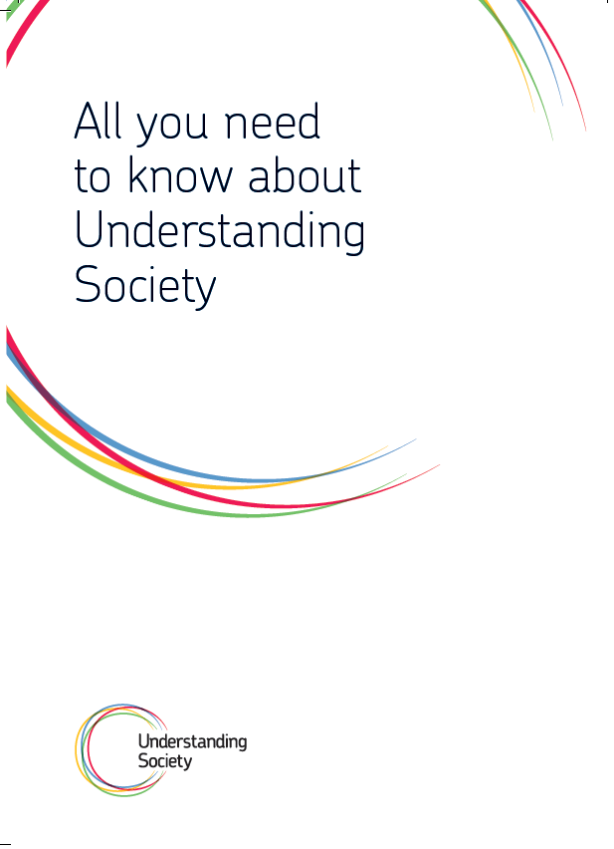

Who to interview
CAPI will determine the eligibility of individuals once you have completed the Household Grid. Generally, you will be interviewing everyone aged 16+ who is part of an eligible household (i.e. where AT LEAST ONE household member was either born outside of the UK or belongs to (or has parents/grandparents that belong to) one of the ethnic minority groups listed in section 6.4.)

We do not want you to interview respondents who are known to you either personally (e.g. a friend, a neighbour, son or daughter of a friend) or in a professional capacity, e.g. a colleague at work, a teacher at night school etc. Refer such cases back to your RFC immediately and the case will be re-allocated.

Definition of a household
When completing the household grid you will need to determine who should be included as part of the household. To do so, use the household definition below:

‘One person living alone or a group of people who either share living accommodation OR share one meal a day and who have the address as their only or main residence.’

Sharing at least one meal a day:
This should consist of the main meal but does not imply that the household must always sit down together for the meal, as long as food is bought for joint use.
Breakfast may be counted as the main meal.

Sharing living accommodation:
Living accommodation in this case is defined as a living or sitting room and also includes addresses where there is no living room separate from the kitchen, i.e., if it forms part of the same room, or where the living room is used as a bedroom.

Shared kitchens and/or bathrooms do not count as shared living accommodation.
Occasionally an individual or a group of people will have both their own living accommodation (that is living room/bedsit and kitchen) and the use of a communal living room. In such cases priority should be given to having their own accommodation, and they should be treated as separate households. Examples of this include warden assisted housing for the elderly, flat let houses, or separate annexes flats where the parent occasionally also uses the family living room.

General points to note:
Members of a household need not be related by blood or marriage.
To be included in the household an individual must sleep at the address when s/he is in residence: anyone who sleeps at one address but has all their meals elsewhere must therefore be included at the address where they sleep.
Some potential sample members might have more than one residence. Where there is doubt, their MAIN residence should be decided by the person themselves.

Normal household residents would also include:
Members (including children of any age) normally living in the household but temporarily away, e.g. on a short course or temporary job likely to last less than 6 months;
Au-pairs, or anyone else on long-term engagement in the household (6 months or more), even if they have their main residence elsewhere;
People who are temporarily resident at the address (e.g. guests) unless they have a date of departure. Boarders should be included, even if they have not been there for six months, unless they know they are moving out within the next six months.

If in doubt about residence, apply the six month rule: those away or likely to be away for 6 months or more are NOT counted as residents at the address (except for those who are ‘absent’ – see below): in some cases their main residence will not be in this country.

Include absent household members
Absent household members include people who are normally resident in the household but are presently at boarding school, in university halls of residence, in institutions or working away, e.g. people who work away from home for whom this is their only fixed or main dwelling unit (e.g., on business, in the armed services, fishermen, oil rig workers or merchant seamen). This would apply even if the household member has been away for more than 6 months. In this case the person should be recorded as still in the household, if this is still their main residence.

This is because these people are not part of another private household and so would not otherwise have a chance of being sampled for the survey.

Students living in private housing (rather than a halls of residence) when away studying are not included as absent household members, as they have their own chance of selection into the sample at their university address.

The CAPI script specifically prompts for the inclusion of household members that are absent, so you should enter their details in when the script prompts you to.

Non-resident household members
The following are NOT regarded as eligible household members:
People working away from home and who only come home at weekends or holidays and for whom it is not their main address;
Spouses who are separated (whether or not they visit the household);
Children who have been (or are expected to be) in care for 6 months or more;
Household members who have been away continuously for 6 months or more;
Paying guests, e.g., in a bed and breakfast;
Anyone not sleeping at the address – to be counted as resident an individual must sleep at the address. Anyone who has their meals at one address but sleeps elsewhere must be included at the address where they sleep.

Summary
In summary, we include the following three groups of people as household residents, including two groups that would normally be excluded from studies:
Group 1: Normal household residents (using the standard household definition);
Group 2: Absent household members (at school / university); and,
Group 3: Absent household members (working away or in institutions).

You should attempt to get a full individual interview with all adults from group 1 or a proxy if this is not possible.

For individuals from groups 2 or 3 – we do not expect you to achieve an interview with them at this wave. When the household grid has been completed these individuals will automatically be given an outcome code (568) to indicate that they are absent. If they happen to be at home during the fieldwork period you can interview them, if they are away please aim to complete a proxy interview for them.

The Electronic Contact Sheet (ECS)
The management of your assignment is done through the Electronic Contact Sheet (ECS). The ECS sits at the beginning of the interviewing script (accessed through Screen 0 in the eReps grid). This is where all information about your contact with the address should be entered.

It is important that you record every contact attempt made at an address on the ECS and send this information back to us electronically at the end of each working day. In cases where you are interviewing a large household you are very likely to have to make multiple trips to complete all interviews. Please keep track of these trips in ECS (using Screen 0).

This is crucially important information since it provides us with information such as:
- the days and times you call at an address;
- the final household and individual outcomes you achieve at that address;
- the area characteristics that you record; and
- any other notes or information that may be relevant in terms of the location of an address, any relevant details about contact made,

You will need to be familiar with the ECS and be clear about how it is used during your assignment and the different types of procedures and information that you will need to carry out at each address. If in doubt please call your RFC.

The information you record on the ECS needs to be sent back to us electronically at the end of each working day.

The ECS has three crucial functions:
- is it is an important record for you in terms of managing your own assignment;
- it is an important source of reference for interviewers who are doing re-issue assignments since they will be able to look at your call patterns and read any notes to help them try and achieve an interview; and
- the information reported back from the ECS is used by Head Office and by TNS BMRB researchers to monitor the progress of the study across the whole country. Outcomes reported back by you are also sent to the University of Essex on a daily basis so that they can monitor the progress of the study.

For all these reasons it is absolutely essential to the success of the whole study that Electronic Contact Sheets are filled in as accurately as possible. A good rule to use when completing the ECS is to always make sure you have completed it in a way where you yourself would be happy to get the information you have included if you were doing a re-issue assignment.

The addresses in your assignment are listed on the eReps grid.

To enter call details for an address you should click on the address line and press the ‘Start Screener/Int’ button. You should always start the interview via screen 0 to complete the screener and household grid before doing anything else.

The household grid and household questionnaire are on screen 0.

Individual interviews are completed on screen 1 onwards (one screen per individual). As the IEMB is made up of fresh sample only, there are no individuals associated with screens 1 – 16 until after the household grid has been completed. After your first call, if you have not completed the HH Grid, Screens 1+ may disappear; these will be displayed once the HH grid has been completed (i.e. after you have collected details on the Household members).

Outcome codes
There are outcome codes which you should use before you have conducted the screening and other codes which can only be used with households once it has been ascertained that they are eligible to take part in the study. The CAPI script will show you filtered lists of outcome codes depending on the information that you enter into the ECS.

A full list of the outcome codes that can be used in the IEMB has been included in the Appendix.

Final outcomes
Remember you must report a Final Outcome Code for each of the addresses that have been issued to you – whether or not you have actually achieved an interview.

A Final Outcome Code should only be completed after you have made ALL your calls at an address. You would, for example, only code a non-contact as a final outcome after you have made a minimum of 6 calls at the address. You would not report a non-contact as a final outcome after your first or second call.

If you do not manage to get an interview, please record as much information as possible about why. If you get a refusal, please also give as much information as possible on reasons for refusal on the notes page of the ECS, as this is extremely useful for those working on re-issues.

If you strongly feel that an address should NOT be re-issued please code this at the appropriate screen in the ECS - and add full details on why the address should not be re-issued. Please note that we will still re-issue contacts where the DO NOT re-issue box has been selected if the reasons given are not felt to be valid or if no information is given.

If you obtain an interview at the sample address the ECS should automatically populate a full/partial interview outcome in the eReps grid.

Interim outcomes
As well as the final outcome codes there are also a number of interim codes you will be using to record the outcome of each visit before the ‘final outcome’ has been achieved. In these cases you will need to continue making calls until a final outcome is achieved.

Every call at an address must be recorded with either an interim or a final outcome code depending on which is appropriate.

Observations at issued address
There are ten observation questions which you need to answer about each address issued to you. Observation questions will only need to be recorded once for each address, regardless of the number of dwelling units or households.

All questions in this section should be answered before making contact with the address. We are interested in your initial observations and judgement, so even if you later discover that your initial observations were incorrect, e.g., if you recorded that the address doesn’t have children under 10 years of age but later found out that there were children of that age living at the address, do not change your observations.

Observation questions need to be completed for all non-deadwood addresses including office refusals, although you should not contact the latter.

The number of interviewer observation questions for Understanding Society is higher than for a typical survey. This is because we will use these questions to define non-response weights and to predict response and attrition at subsequent waves.

For deadwood addresses you do not need to answer the observation questions. When the ECS asks “Do you wish to complete the observational section now?”, if you know that the address/household is deadwood you should answer “No” and then code the final deadwood outcome.

Eligible households which are non-productive
We will require you to provide some information about households that you determine are eligible for the study but that you are unable to conduct the survey with (language issues, refusals, no contact after conducting the screener etc.).

This forms part of the ECS and when you code a final outcome for the household you will be prompted to provide:
- The reason for refusals
- The following details about the main person you spoke to when you made contact at the address:
  - Age
  - Sex
  - Ethnicity
  - Whether English was their first language
- Whether you established how many people lived in the household and if so, how many were aged 16+, 10-15 and 0-9.

The CAPI script will guide you through these questions at the appropriate time.

Capi name
The sample will be issued in four batches; each of these will have unique references in your EReps gird. The CAPI names are as follows:

EB15Q1 | Q1 - For fieldwork beginning on 04/04/2015
EB15Q2 | Q2 – For fieldwork beginning on 16/06/2015
EB15Q3 | Q3 – For fieldwork beginning on 25/08/2015
EB15Q4 | Q4 – For fieldwork beginning on 04/11/2015

Occasionally you may be instructed by the CAPI Helpline to access the script via Dimensions IRunner in which case please follow the instructions as given at the time.

The interview process

Overview of data collection instruments
The data collection instruments and their average timings are:
5 min CAPI household grid;
10 min CAPI household questionnaire;
30 min Individual Adult CAPI questionnaire for all aged 16+ (including 5 min CASI); and
10 min CAPI proxy questionnaire.

The adult interview contains extensive routing, so individual interview lengths will vary considerably. The main factors that will affect individual interview length are whether the respondent was born in the UK, their employment status, the number of children in the household and whether the respondent receives state benefits.

Planning your work/tracking progress
If you have a large household you are very likely to have to make multiple trips to complete all interviews.

Showcards
You have a specific set of showcards for the IEMB (with a red front cover) – do not mix these up with W6, W7 or IP8 showcards.

CAPI interview
There are several elements to the CAPI questionnaire, which are covered in detail in this section.

Household Grid
The household grid can be completed with any adult (16+) household member.

In the household grid details on all members of the household will be collected, as well as some basic details on relationships, ethnicity and where people have lived since 1991.

We would like you to collect the details of absent household members in the grid, this includes:
People absent in university halls of residence or boarding schools but who come home at the holidays
Anyone who normally lives at the address but is away at the moment
Household members presently resident in institutional accommodation
The grid has questions which specifically prompt for this information. Please refer to section 7.2 for further details.

Completing the household grid should take 5 minutes on average, although this will vary considerably depending on household size.

Household questionnaire
The household questionnaire should be conducted with either the householder or their spouse/partner. The householder is the person who owns or rents the accommodation. This is because the household questionnaire asks about things like mortgage and rent payments, household bills, money spent on food etc. So someone who is able to answer these questions needs to complete the household questionnaire.

The household questionnaire should take 10 minutes on average.

Individual CAPI interviews
All adults aged 16 and over at the point at which the household grid is completed should complete an individual CAPI interview. The only people that should not be interviewed are those that are absent (e.g. those in halls of residence/boarding school/institutional accommodation). The CAPI script will take care of this for you by assigning an outcome to these individuals (of 568) so that you can easily identify them. If they happen to be at the household when you make contact then you can conduct the interview with them, however, in most cases we expect you to conduct a proxy interview about them at this wave.

The interview lasts around 30 minutes, including the CASI section.

It is important to note that some of the topic areas covered in CAPI are sensitive and should be treated accordingly. The areas that some sample members might find particularly sensitive are fertility (including pregnancy and child birth history questions), previous relationships, financial questions (such as earnings and investments) and receipt of state benefits. For these reasons, it is extremely important that wherever possible you interview the sample member alone and in private so they feel comfortable providing you with this information. It also helps to reassure them that the information they give you is confidential and no-one else will be seeing their answers.

Please familiarise yourself with the different types of benefits listed in
Appendix B in order to be able to answer queries from respondents in the module ‘Unearned income and state benefits’. Please note that ‘winter fuel allowance/payment’ does not count as a type of benefit for Understanding Society, and does not have to be recorded here.

Help Screens
Information about individual questions will be found in the CAPI help screens rather than in these project instructions. There are many more help screens than you would find in a usual CAPI program, and you can access them by selecting the HELP link which appears on screen at particular questions.

Search box
At CAPI questions which code the county respondents were born in, the school that they went to and the county they lived in in 2010 you will need to search from the extensive list of options available from our look-up files. There is a box on screen within which you have to start to type the first letters of the county/school and the relevant location is then displayed. There are further instructions provided within the CAPI screen at the relevant locations.

N.B. - If a respondent was born within Greater London the most efficient way of coding this response is to type LON and "Greater London" will appear.

Proxy interviews
You should attempt to get a full individual interview with all respondents. You should not take a proxy interview unless you are absolutely sure that you are unable to get a productive interview during the 10 week fieldwork period. For example, if one adult is out when you first call, then you must make another visit to attempt to interview them rather than taking a proxy interview from someone else.

You should aim to complete a proxy interview for household members that are absent (given an outcome of 568 once the grid is completed).

There are certain criteria for determining whether someone can act as a proxy. A proxy respondent must be an adult aged 16 or over and either:
a close relative;
another adult in the household who knows the respondent well; or
be nominated by the non-participant.

In all cooperating households proxy interviews should always be attempted unless the respondent explicitly refuses to have any information about them collected.

Adult CASI
Adults will be asked to complete a computer-assisted self-completion (CASI) (average duration: 5 mins) during their CAPI interview which covers the following areas:
Health
Relationships

Completion by interviewer
You will be asked to record at the beginning of the self-completion section whether the respondent will complete the CASI themselves or whether the interviewer will ask the questions, because the respondent is unable to complete it themselves, for example because of sight/ reading/ language problems.

Security of answers
At the end of the self-completion section, you will be prompted to enter your interviewer number in order to lock the answers given by the respondent. After doing this, you will no longer be able to access the self-completion section. Please check that the respondent does not want to change any of their answers before locking the self-completion.

Recording contact details
It is hugely important that we obtain as much contact information as possible about the respondents. One of the biggest challenges for longitudinal studies is finding people who have moved since their last interview. The more information we can collect about how to contact them at this interview, the better chance we have of finding them in the future.

At the end of the individual interview the CAPI will prompt you to collect contact information for the respondent. We want to collect telephone numbers (both mobile and landline phones) and email addresses. If a respondent is adamant that they don't want to be contacted again, then there is a code to use in CAPI at the point that contact details are collected.

As Understanding Society is a longitudinal study and we will be contacting and visiting respondents on a yearly basis, it is very important to ensure that ALL names, addresses and job titles are spelt correctly. Such details are used for mailing respondents and obviously their details need to be correct so that we create a good impression and materials are sent to the correct person at the correct address.

Stable contacts
You also need to collect stable contact details for each adult sample member. For the IEMB we are actually attempting to collect contact details for two stable contacts – this is to increase the chance of us being able to track down sample members that move. Although this may appear to be time consuming, it is less onerous than having to trace sample members when they have moved.

Where necessary, please reassure respondents the stable contacts will only be approached in the event the person moves and we are unable to trace them. We will only ask the stable contact whether they have contact details for the sample member, the stable contact person will not become part of the study and the sample member is not ‘signing them up’ to any obligation.

Please also remember that we would like different stable contacts for each person in the household. The more contact details we have, the better chances we have of finding our movers.

Collecting details about respondents’ occupations
For all interviewed adults who are in work you will be required to record their job description as described below.

For Understanding Society there is a requirement to code the Standard Industrial Classification (SIC) to 4 digits rather than to the standard 2.
To code to 4 digits, the Operations team needs very detailed information e.g., if someone works in a shop, it is not sufficient to record “clothes shop” – we need to know what kind of shop and what their duties are (e.g., are they the owner, manager or do they work on the till, stockroom etc), so probing is essential.

For example, if someone works in clothing manufacture –Figure 14.1 below shows that “clothing manufacture” would not be sufficient in this case – you need to probe for exactly what is made and what it is made with. If more than one product or material is used you need to probe for what product is made the most. Note that you need to record what the organisation they work for makes, not just what they make within their role. If they can’t tell you, write in everything they make and what they make it with.

The different 4 digit SIC codes for the manufacture of clothing for men, women and children are illustrated below:

Figure 14.1 4 Digit coding for manufacture of clothing
4 digit SIC Code | Type of manufacture
1413 | Manufacture of outer wear coats/suits/jackets/ trousers/skirts
1414 | Manufacture of underwear/nightwear/shirts/blouses
1419 | Manufacture of babies garments, gloves/ties/shawls/hairnets etc
1411 | Manufacture of leather goods, except sports gloves and sports headgear
1431 | Manufacture of other knitted goods: socks, tights
1439 | Manufacture of other knitted goods: pullovers, cardigans

From Figure 14.2 below you will also notice that 4 digit SIC coding requires greater detail than 2 digit. ‘Glass manufacture’ would be sufficient for 2 digit SIC coding but to code to the 4 digit SIC level, you would need to find out what type of glass was manufactured.

Figure 14.2 4 Digit coding for glass manufacture
4 digit SIC Code | Type of manufacture
2314 | Manufacture of glass fibres
2313 | Manufacture of glass inners for vacuum flasks
2312 | Manufacture of glass mirrors
2391 | Manufacture of glass paper
2319 | Manufacture of glass wear for laboratory

Similarly, for teaching, just knowing that someone teaches in secondary education is not sufficient and more probing would be needed to determine what types of subjects and level of qualifications are taught. Figure 14.3 illustrates 4 digit coding for teaching.

Figure 14.3 4 Digit coding for teaching
2 digit SIC Code | 4 digit SIC Code
 | 85.10: Pre-primary education
 | 85.20: Primary education.
85.3: Secondary education. | 85.31: General secondary education.  85.32: Technical and vocational secondary education.
85.4: Higher education. | 85.41: Post-secondary non-tertiary education  85.42: Tertiary education.
85.5: Other education. | 85.51: Sport and recreation education  85.52: Cultural education  85.53: Driving school activities  85.59: Other education n.e.c.
 | 85.60: Educational support activities

The end of the interview

COA card, thank you leaflet and MRS leaflet
At the end of the individual interview you will be prompted to hand over a change of address (COA) card and a University of Essex freepost return envelope. The CAPI screen will also prompt you to copy the following information from the screen onto the back of the card:
Respondent name (first name and surname);
Respondent’s 14 digit Personal Identifier (PID); and,

Please ensure you copy the details from the CAPI screen to the COA card accurately as these will be returned to ISER should the sample member move address, and ISER will subsequently have to update their records based on the information that you have transcribed.

You will also be prompted to provide respondents with a Thank you leaflet and a MRS leaflet at the end of the interview. Please make sure that you complete the information on the front of the MRS leaflet.

Incentives
No incentives have been sent out in advance for the IEMB – you will be required to give them out at the end of the individual adult interview. The incentive is £10 for each adult that completes a full interview (i.e. not the proxy) and the incentive takes the form of a Love2Shop gift card.

Administration of incentives
The CAPI script will prompt you to hand out the gift card and will ask you to enter the serial number from the back of the card. Please make sure you enter this carefully as any mistake may result in the card not being activated. Please remind the respondent that they will need to wait three working days for the card to be activated before they can use it.

Your work pack will include a supply of gift cards. If you require additional cards, contact your RFC.

It is critical that you connect your CAPI machine at the end of every day that you work. This will send information back to the office about the incentives and will ensure that they are activated as quickly as possible.

The list of retailers where Love2shop vouchers can be redeemed changes regularly. Please consult http://www.highstreetvouchers.com/gift-vouchers/love2shop for the latest list of retailers where they can be used.

At the time of publication of these instructions, the gift cards were valid at the following locations:

General Merchandise & Department Stores
Argos
Boots
Debenhams
HMV
House of Fraser
Littlewoods Clearance
Matalan*
The Original Factory Shop
TK Maxx
Toys 'R' Us
TJ Hughes
WHSmith*
Wilko
£-Stretcher

Fashion & Footwear
Bhs*
Blue Inc
Bonmarche
Boux Avenue
Brantano
Faith*
Greenwoods
Jones Bootmaker
Lakeland Leather
Matalan*
New Look
Oasis
Officers Club
Peacocks
Petroleum
Principles*
River Island
Select
Shoe Zone
Slaters
Stead & Simpson
Store Twenty One
The Edinburgh Woolen Mill
Warehouse

Specialist Retailers
Chelsea FC Megastore
Denby
Eason
Euronics*
LFC
Optical Express
Ryman*
Semichem
Superdrug
The Perfume Shop
The Works
Waterstones
Walmsley's

Watches & Jewellery
Beaverbrooks
Ernest Jones
Fraser Hart
Goldsmiths
H.Samuel
ROX Diamonds & Thrills
Leslie Davis
Mappin & Webb
Watches of Switzerland

Sports, Outdoor & Motoring
American Golf
DW Sports Fitness
Halfords*
Segkind - Segway Experience Days
Sporting Pro
Home Improvement & Soft Furnishings
Bensons for Beds
Homebase
Ponden Home Interiors
Robert Dyas
The Linen Warehouse
Yorkshire Linen Co.

Babies & Childrenswear
Babies 'R' Us
Early Learning Centre
Mothercare

Food & Drink
Baker & Spice
Bella Italia
Cafe Rouge
Druckers Vienna Patisserie
Hard Rock Cafe*
Iceland*
Laithwaites*
Patisserie Valerie
Spaghetti House*
Planet Hollywood*
The Gourmet Society
Thorntons
West Cornwall Pasty Co.

Leisure & Pleasure
The Alton Towers Resort*
Blackpool Pleasure Beach
Britannia Hotels*
Champneys
Chessington World of Adventures*
Drayton Manor*
Gulliver's Theme Parks
Hastings Hotels
LEGOLAND Discovery Centre Manchester*
LEGOLAND Windsor*
Lightwater Valley*
London Bridge Experience
London Tombs
Madame Tussauds*
Marriott Hotels*
Pontin's
Red Letter Days
Ripley's Believe It or Not! London
Silverstone Rally School
SpaSeekers
Tenpin
Thomas Land*
THORPE PARK*
Unique Track Days
Warwick Castle*
Wookey Hole Cave

*Restrictions apply to some retailers

Translations
The IEMB questionnaire has been translated into nine languages, some of which are similar to the main wave:

Figure 16.1 – Languages offered
 | IEMB | W6 | W7
Bengali
Gujarati
Punjabi (Gurmukhi script)
Punjabi (Urdu script)
Somali
Urdu
Polish
Portuguese
Turkish
Arabic
Cantonese
Welsh

Translation requests need to be recorded in the CAPI by assigning a whole household or individual needing translation a specific outcome code:

Figure 16.2 – Outcome codes
 | IEMB outcome code
Household translator requests | outcome 188 to 199 (one for each language)
Individual translator requests | outcome 688 to 699 (one for each language).

It is very important to use these outcome codes, as the team will be relying on them to identify translation requests. It is useful to have any other notes and comments about the translation cases too, but you should not rely solely on notes or memos to record translation requests.

You will also need to contact the office as soon as you identify any cases with either whole or partial translation requests for instructions on how to proceed.

Please note that households/individuals requiring translation into one of the nine survey languages should NOT be coded as ‘Language difficulties’ (household outcome code 67 or individual outcome code 567). These are final unproductive codes intended be used only in cases where people don’t speak English or any of the nine translated languages and there is no-one available in the household/family/neighbour to translate for them. Using these codes for households/individuals who could still be interviewed in translation means these translation cases will be missed.

Conducting interviews in translation
If the person who answers the door does not speak English, ascertain if anyone in the household does speak English or one of the nine official IEMB languages listed above by using the Translation card.

If at least one person speaks English, complete the screener, household grid, household questionnaire and individual interviews with those who do speak English. Then code an individual outcome for non-English speaking adults in the household who speak one of the nine official languages.

If nobody in the house speaks English, but at least one person speaks one of the nine IEMB languages please write down the telephone number for the household (the text in the translation booklet asks for this in each language), code a household outcome requesting an interpreter or accredited interviewer for the required language and get in touch with your RFC.

We provide three main types of translation for non-English speakers who speak one of the nine IEMB languages:
An accredited TNS interviewer will conduct the interview using the translated script;
Another TNS interviewer will accompany you to conduct the Understanding Society interview using the translated script;
An external agency interpreter will accompany you to conduct the Understanding Society interview using the translated script.

Your RFC will advise you as to which method will be used in your case. The only exception is accredited interviewers, who may proceed to conduct the interview using the relevant translated script if they encounter a household who speak the language they are accredited in.

If you are not accredited but speak one of the Understanding Society languages, please get in touch with your RFC to arrange an accreditation.

The translation flowchart below shows the process and order for interviews to be conducted in languages other than English:

Figure 16.3 Translation flow chart

If you identify a translation requirement:
Select the correct outcome code in the ECS
Synchronise your CAPI machine so that this is sent back to head office

Head office will be checking outcome codes on a weekly basis
If it’s a request for a language in an area where we have an accredited interviewer it will be reallocated within a week and the interview will be conducted shortly after
If it requires an external translator:
  - You will be contacted by head office, asking you to make an appointment for translated interviews (giving at least one week’s notice)
  - Once this appointment has been made a translator will be booked to accompany you
  - In all, the interview is likely to take place 3-4 weeks after the requirement was first identified

Accessing translations
You can set the language in which the interview is to be conducted in three different places:
At the start of the HH grid
At the start of the HH questionnaire
At the start of the individual interview

Before you start the interview properly you will be asked whether the interview will be conducted in English – select “No”. Then select the language in which the interview will be conducted.

Due to the high number of languages offered, some translations are stored in a different script.

In the main script: Bengali, Gujarati, Punjabi Urdu, Urdu

EBTRAN/EBTRANIV: are used for Somali, Polish, Portuguese, Turkish and Punjabi (Gurmukhi)

To access all translations, go into the main script and code the language you require. If you select a language that is not in the main script, the script will prompt you to exit the interview and enter EBTRAN or EBTRANIV via iRunner
EBTRAN is used for the HH grid or HH interview
EBTRANIV is used for Individual interview

The script will display a screen with instructions and information that you need to enter when you go into the script through iRunner:
The project name to enter when you first go to iRunner
The CAPI name for the sample
The serial
The screen number

Make sure to write this information down when it is displayed, you will not be able to go into the language script without it. The information you need to write down is indicated in the screen shot below.

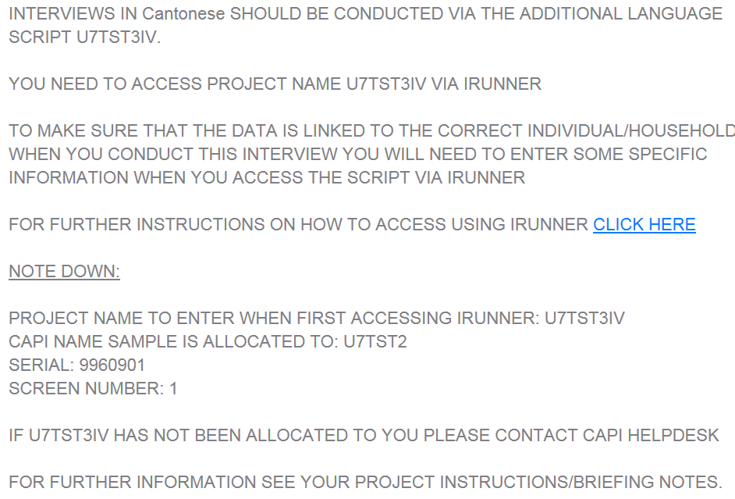

Record all of this information carefully

To access the survey via iRunner:
- Pause the interview and exit Ereps to get back to the CAPI home screen. Then click on “dimensions”
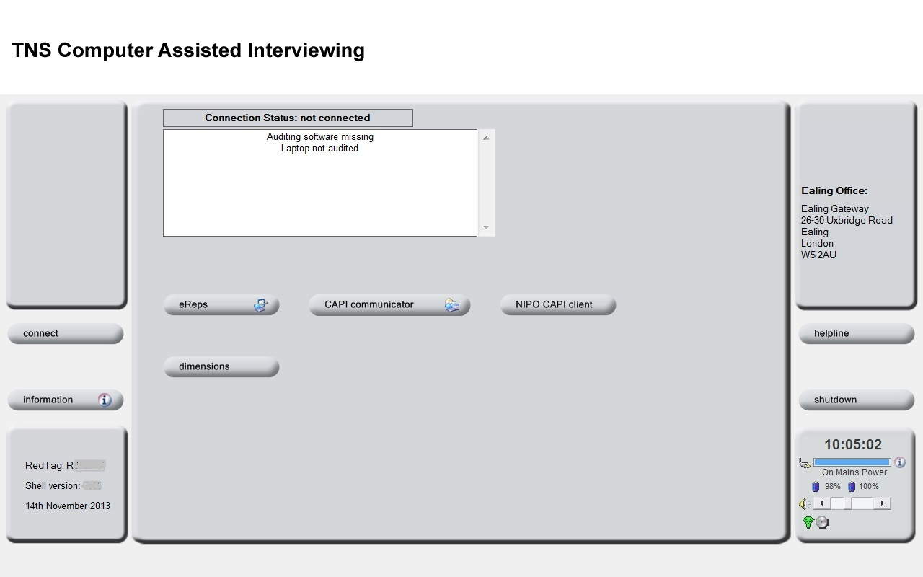
Click here

- Click on “IRunner”.in the box that pops up

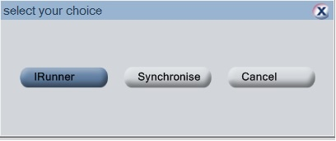

Click here

- You will then need to enter the project name that you want to access (this was part of the information that was given to you earlier and that you wrote down). You should leave the restart code box blank.

- On the subsequent screen you will need to select the CAPI name for the sample and enter the serial and screen number. The interview will then launch in the selected language.

NB: To log all visits and conduct any other interviews at the household please use the regular script!

Translated documents
The following materials have been translated and must be used for translated interviews:
Change of address cards
Information leaflets (“All you need to know about Understanding Society”)
Showcards
MRS leaflet
Thank you flyer

If you are an accredited interviewer working on IEMB and do not have these materials, please contact your RFC as soon as possible and wait to receive your pack before conducting any interviews in translation.

Non survey languages
If a respondent does not speak one of the nine IEMB languages but there is a member of the household (aged 14+) who can translate for them you may conduct the interview using this method. However, if you think that you need to use a household translator, please get in touch with your RFC before conducting the interview as this method can only be used with prior office approval.

If a respondent does not speak one of the nine IEMB languages and there is nobody in the household who can translate for them, conduct a proxy interview where possible or give the individual an outcome code of 567. Please see section 11 for more information on proxy interviews.

If a whole household does not speak English or any of the nine translated languages and another household member (aged 14+) is not available, find out which language they speak using the translation card and enter it into the ECS and give the household a final outcome of 27 (Residential: unknown if eligible person(s) due to language barrier)

For households which are screened into the study but within which not all members speak English - you can complete the screener, household grid, household questionnaire and individual interviews with those that speak English. Any adult household members who don’t speak English or one of the nine IEMB languages should be given an individual outcome code of 567 if a household translator (aged 14+) is not available.

Note that you should record the following outcomes for respondents who do not speak English or one of the nine IEMB languages:
27 (Residential: unknown if eligible person(s) due to language barrier) for whole households that do not speak English or where you are unable to conduct the screening due to language issues.
567 ‘Language difficulties’, if an individual in the household does not speak English.

Workpack
Your work pack for IEMB should contain the following documents. If anything is missing or you need extra copies, contact your RFC.

Number | Document
AREA SPECIFIC | IEMB_12 Your assignment – summarises the number of addresses in your assignment and gives an indication of how many may screen in – SAMPLE SPECIFIC
AREA SPECIFIC | Assignment Map – SAMPLE SPECIFIC
5 | Advance mailing
Depends on area* | IEMB_1 12411614IEMB Thank You Flyer (GB&NI)
Depends on area* | IEMB_2 11834399 GB MRS leaflet-1
Depends on area* | Love to Shop Gift Cards
1 | IEMB_3 Police Form – August 2014 IEMB VERSION
1 | IEMB_4 IEMB Showcards
Depends on area* | IEMB_5 11834325 Change of Address Card
Depends on area* | IEMB_6 11834313 Interviewer Card
Depends on area* | IEMB_7 124116 IEMB Leaflet GB_AW – colour print on glossy paper
1 | IEMB_8 124116 IEMB Screening Card v2 LAMINATED
1 | IEMB_9 Translation booklet
1 | IEMB_10 Translation card
1 | IEMB_11 IEMB Translation Flowchart
1 | Freepost C4 brown peel and seal envelopes addressed to High Wycombe

*As the size of assignments is variable the number of each of these documents will vary from pack to pack.

Admin and return of work
Before you start work
You should read these instructions carefully and go through the questionnaire a few times (using the practice serial numbers provided) to make sure that you are used to the interview process and the various instructions and so that you are also aware of the sort of questions that appear in the self-completion section.
Also ensure you are comfortable with the Electronic Contact Sheet script and have made a number of ‘practice calls’ before you go out. Refer to the ECS Guidelines and contact the CAPI Helpline if you have any questions.

In addition, you should ensure that your computer batteries are fully charged. If you have a spare battery, then you should charge it up and take it along as well. The CAPI name used for all functions (logging your ECS calls, completing the HH Grid; the HH Interview and Individual Interviews) changes for each sample issue.

Connecting
You MUST get into a regular habit of connecting each day before you work on Understanding Society. We will be sending you emails regarding opt outs and cancelled appointments that may affect your work schedule for the day.

Return of work
After each day’s interviewing, you should complete your DAYREC and send both your DAYREC and all your interviews via your modem overnight.

Payment
Please refer to the Paychart in your workpack for details on pay.

If you have any queries about anything covered by these instructions please contact your RFC - they should always be your first point of contact if you have any field issues and you should contact the CAPI Helpline if you have any technical issues on 0800 015 2103.

Top Tips for new interviewers
The following list has been collated from comments and suggestions made by other interviewers working on the main Understanding Society survey / IEMB dress rehearsal:

Be organised
- It’s very important to be organised (things like ordering your addresses based on how you are going to visit them) – spending a bit more time getting organised at home will save you time once you’re out visiting the addresses.

- Look at location of addresses on streetmap/google maps to check where they are

- Don’t expect to do any interviewing on the first day – use it to go round your addresses and conduct the observation questions– conduct the screening as early on as possible. Good idea to do these first visits in daylight – particularly in rural areas where it might make it easier to find the addresses.

- Read up about the study before you start – then be enthusiastic about it

- Expect it to take you 7 or 8 weeks to finish your assignment – probably can’t do it in a month.

- You could print your contact details onto sticky labels to add to the calling card along with a personal message – saves time and easier to read

- Once you know a household has screened in to the study –
  - identify the person who will help you organise the HH to take part (often wife/mother).

  - For larger HHs, spreading interviewing over more than one visit can make it seem shorter for them (and easier for you)

Be patient and flexible
- Step back a bit at the door – give them space

- Your first call is “I’m here to introduce myself” then try to conduct screening – even if they qualify, they are unlikely to take part then and there.

- Many respondents react better if you give them options rather than trying to fit them in to your schedule

- Be prepared to make lots of visits

- Be honest about how long it’s going to take

- Don’t expect each interview to be the same– they are highly variable.

Once a household has screened in to the study, do:
- Assume people are going to take part (makes it harder to say no)

- Try to interview people on their own – and it’s fine to ask people to do this (even with 16/17 year olds) but you have to accept it if they say no.

- Take a little time over the grid – don’t rush through it

- Keep it light and friendly – this is a fun thing to be involved in.

- Put a card through the door - some people will phone you back.

- Mention incentive early on (for screened-in households)

- Know when to back off

- Show interest in the family and tell them how important they are

- Be shocked and upset if people say they don’t want to take part: “But you’re so lucky to have been selected!”

- During the interview let them know what you’re doing if there are pauses e.g., “Now we’ve finished the household interview I’m just opening up your individual interview”

- Explain pauses by saying that you’re ensuring their answers are saved successfully.

- Give the respondents the headlines document or a case study laminate to read during pauses

Don’t
- Don’t book appointments too close to each other

- Don’t overbook yourself as you may need to rearrange appointments

Appendix A. Common queries and objections
The following are examples of common reasons respondents give for not taking in part in studies such as Understanding Society. Underneath each reason is a possible response that you can give:

“I don’t have time to do the survey”
IF THEY HAVE NOT DONE THE SCREENER YET:
We are seeking to conduct interviews with particular groups of people. I am just making an initial contact today to see whether your household qualifies for the study – it should only take a few minutes to determine this.

IF THEY ARE SCREENED IN TO THE STUDY:
I can come back at a time that suits you. Can I make an appointment at a more suitable time?

“What difference is it going to make?”
The study covers important subjects such as your health, your opinions, your family and your job. The information collected can inform Government policy and is used by academics, policy-makers and researchers working for charities and the voluntary sector in this country and abroad.

Also show the case studies and direct the person to www.understandingsociety.ac.uk for further examples

“I never take part in market research!”
This is not market but social research. This study is being done on behalf of the University of Essex. The information collected can inform Government policy and is used by academics, policy-makers and researchers working for charities and the voluntary sector in this country and abroad.

Also show the case studies and direct the person to www.understandingsociety.ac.uk for further examples

“I can never get everyone together at the same time”
The household does not have to be done at the same time. You can make appointments to suit their availability where appropriate.

“Questions are too personal”
They don’t have to answer every question, they can refuse to answer any question they want – the questions they do answer are still important to us

“I’m too busy with work”
This is the most important group in the study, because of the numbers of people that are retired, unemployed or looking after the home or family, we need all the information that only full-time workers can give us to have an accurate view of working life in Britain

“I’m not interested in the subject of the survey”
The study covers wide range of topics such as your health, politics, your opinions, life satisfaction, your family background and your job. Taking part gives you a chance to tell me about your life story.

“What is the point for someone my age – I’m too old for these things!”
Everybody’s opinions count – we are interested in hearing about your ideas and experiences.

“I’m worried about the confidentiality of my answers”
We are governed by the Data Protection Act, we guarantee that no information you give can be linked back to you. Only specific people have access to the computer with your details. The files are encrypted and protected by high-level security. Your personal details are never put onto CDs or sent through the post. Results using the information will be in the form of percentages in tables, so individuals or households will never be identified.

Appendix B. Benefits module details
List of benefits that appear in Benefits Module with explanations:

Question name and Benefit name | Further details on the benefit
BenPen  NI  Retirement Pension | For married couples, you should try to get the separate amount paid for the respondent rather than any joint amount. If the respondent is unable to separate it, show the whole amount received and record it as received jointly.  If the wife is aged under 60 she may not receive a state pension in her own right. Be sure to query whether she receives any in her own right otherwise any NI pension income would be solely the husband’s.  Retirement Pensions may have an earnings related supplement. This is normally paid on the same order book and should be included in the amount recorded.
BenPen  Occupational Pensions from previous employers | Include all employer’s pensions not just retirement pensions. Include pensions paid before retirement (i.e., a respondent may still be working for an employer but has become entitled to receive payments) and pensions paid for early retirement.
BenPen  Pension from a spouse’s previous employer | Women may also be receiving an occupational pension in respect of a deceased spouse: these should be recorded as 03. Check that any amount recorded is net of tax and other deductions. Do not include pensions from a Trade Union or Friendly Society unless the pension is received as a direct result of the respondent’s employment by them.
BenPen  Widow’s Pension/War Widow’s Pension/ Widowed Mother’s Allowance /Widowed Parent’s Allowance / Bereavement Allowance | Do not include Widow’s Benefit, Widow’s Payment, or Bereavement Payment as these are single lump sum payments.
BenPen  Pension Credit | This is a means tested benefit paid to pensioners. They will not receive it unless they have applied for it and qualification is dependent on income and assets.  Pension Credit has been paid since October 2003. There are two main elements. The Guarantee Credit is the minimum amount a pensioner can be expected to live on. There will be additional amounts for owner occupiers’ housing costs, for disability and for caring responsibilities. The Saving Credit is available only to pensioners age 65 and over and aims to reward those who have made provision for their retirement over and above the state pension.  Pension Credit will be amended from October 2014 to include help with eligible rent and dependent children.
BenDis BenEsa  Employment and Support Allowance | This is a new means tested benefit that replaced ‘Incapacity Benefit’ and ‘Income Support (paid on incapacity grounds)’ from the 27th October 2008.  Anyone receiving Incapacity Benefit or Income Support (paid on incapacity grounds) at the change-over date could continue to receive those benefits, so long as they continue to satisfy the entitlement conditions, however existing recipients are gradually being shifted to ESA. Respondents may also receive income-related Employment and Support Allowance if they require additional financial support for specific reasons, for example, because of housing costs or as a result of disability or caring responsibilities.
BenDis  Severe Disablement Allowance | Is for people of working age who have not been able to work for at least 28 weeks but who cannot get Incapacity Benefit. Married women unable to perform household work may also receive it.
BenDis/BenAl  Industrial Injury Disablement Allowance | Is a variable amount paid to someone disabled through either a work accident or an industrial disease.
BenDis  Disability Living Allowance/ Care Component | Since April 1992 this has replaced Attendance Allowance for people aged between 5 and 66 (although many people will continue to call the allowances by their old names). In addition some people not previously entitled to Attendance Allowance will receive this benefit. Those aged 66 or over will continue to receive Attendance Allowances.  When the person is under 16 the Allowance will normally be paid to the person responsible for them. In such cases it should be recorded as income on the questionnaire for the responsible adult for the child. Where someone is 16 or over this should recorded on person’s own questionnaire.
BenDis  Disability Living Allowance Mobility Component | Paid for those unable, or virtually unable, to walk as a component of Disability Living Allowance. This benefit replaced Mobility Allowance.
BenDis  Personal Independence Payments | From April 2013 Personal Independence Payment (PIP) replaces Disability Living Allowance (DLA) for eligible working age people aged 16 to 64. People aged 65+ who already receive Disability Living Allowance will continue to do so. All working age DLA claimants will undergo an assessment of need.
(BenDis  Attendance Allowance | Paid to people who need high levels of care because of severe disability. Include Constant Attendance Allowance. If paid for a child under 16 include as mother’s income, or if there is no mother then father/guardian.
BenDis  Carer’s Allowance | Weekly paid benefit for people of working age who give up working to look after someone receiving Attendance Allowance. This was formerly known as the Invalid Care Allowance.
BenDis  War Disability Pension | Payable to members of the armed forces disabled in the 1914-18 war or after 2nd September 1939. Merchant seamen and civilians disabled in the Second World War are also eligible. The amount paid varies according to an individual’s rank and the extent of the disability.
BenDis  Incapacity Benefit | This was introduced in April 1995. It replaced NI Sickness Benefit and Invalidity Benefit which officially do not exist any more. If a respondent reports receiving NI Sickness Benefit and/or Invalidity Benefit, code as Incapacity Benefit and record total amount received in grid.
BenBase  Income Support | Income Support replaced Supplementary Benefit (sometimes called Social Security Benefit). From October 2013, no new claims for Income Support will be taken and all potential applicants will be moved to Universal Credit, nevertheless some respondents will continue to receive IS until the transition is complete. The rate is assessed on the grounds of age and marital status with a flat-rate premium for children and special premiums for people such as lone parents, people with disabilities and pensioners.  Income Support is often paid along with other benefits as a supplement. You should try, wherever possible, to record the amount of Income Support separately even in the case where it is paid with Job Seeker’s Allowance or with a state pension. The specific amount paid as Income Support will usually be shown on the cover of the Benefit Order Book.  Any maintenance payments from a former or separated spouse or for child support which are paid through the DWP or other government agencies, should not be included as Income Support or any other benefit.
BenBase  Jobseeker’s Allowance | This replaced Unemployment Benefit in October 1996. Those receiving JSA are capable of work and available for work and actively seeking work and have a current jobseeker’s agreement with the Employment Service. Full-time students, those on temporary release from prison and those receiving maternity allowance or statutory maternity pay are not eligible for JSA. There are two types of JSA - Contribution-based and Income-based. The Contributionbased component is paid in the first 26 weeks of unemployment if enough NI contributions have been paid. The Income-based component is a means-tested benefit (paid after 26 weeks for those who qualify for Contribution-based and pass the means-test).  However, from October 2013, “income based” Jobseeker’s Allowance will be replaced by Universal Credit, though those receiving this type of JSA at that time may continue to receive it until they are transferred to UC.
BenBase  Universal  Credit | From October 2013 Universal Credit replaces Income Support, income-based Job Seeker's Allowance, income-related Employment Support Allowance, Housing Benefit, Child Tax Credit and Working Tax Credit. It can be payable to people who are not working, or who are are in low paid work and will top up their earnings. It will be calculated and delivered electronically and automatically adjusted each month in line with earnings. Claimants will receive just one monthly payment, paid into a bank account in the same way as a monthly salary. Support with housing costs will go direct to the claimant as part of their monthly payment. Universal Credit is made up of a standard allowance and potentially five elements: Child Element / Disabled Child Additions; Childcare Element ; Carer Element; Limited Capability for Work Element; and Housing Element.  The monthly Universal Credit payment covers everyone in a family who qualifies for support including a person claiming for themselves alone, a person claiming for themselves and their child or children, a couple making a joint claim for themselves, or a couple making a joint claim for themselves and their child or children. Children over 18 living with their parents or siblings can claim Universal Credit in their own right.
BenSup  Return to  Work Credit | This is a payment for people starting work of at least 16 hours a week and earning no more than £15,000 per year. Recipients will have been receiving an incapacity benefit (including statutory sick pay) for 13 weeks immediately prior to starting work. It is payable for up to 52 weeks.
BenBase  Child Benefit | Is normally paid to the mother (unless there is none in the household) and should be shown as her income. Where it is paid into a joint bank account the names of both account holders will be on the benefit order book.  This should still be recorded as the mother’s income. Child Benefit (Lone Parent) was withdrawn in July 1998 however single parents responsible for children continuously since July 1998 may continue to receive this. Note, from January 2013 Child Benefit certain higher income families will no longer be eligible to receive Child Benefit.
BenSup/BenTax/ BenCTC  Child Tax Credit | Introduced in April 2003 this is paid to those with at least one dependent child. Child Tax Credit is paid to the person responsible for the care of the child(ren) so can be received by one person only in the household. If the respondent qualifies for the childcare element of Working Tax Credit, this will always be paid with the Child Tax Credit, even if the respondent is not themselves in receipt of Working Tax Credit.  In 2013 Universal Credit was introduced to replace six benefits including Child Tax Credit. The process of transferring claimants from Child Tax Credit to Universal Credit is scheduled to take until 2017 therefore respondents may still be receiving Child Tax Credit
BenSup/BenTax  Working Tax Credit | This replaced Working Families Tax Credit and the Disabled Person’s Tax Credit in April 2003. It is paid to families with at least one dependent child or those with a disability who are working. In some cases it can be paid alongside JSA or income support for those not working. It is paid either as a tax credit through the respondent’s pay check or as a direct benefit. It can also be paid as a lump sum covering a period of 26 weeks in some cases.  Please note: Where a married or cohabiting couple are receiving WTC, they apply for the tax credit jointly but cannot be receiving it jointly. They will have had to say which couple member was to receive the benefit or tax credit.  .  In 2013 Universal Credit was introduced to replace six benefits including Working Tax Credit. The process of transferring claimants from Working Tax Credit to Universal Credit is scheduled to take until 2017, therefore respondents may still be receiving this benefit.
BenSup/BenTax  Disabled Person’s Tax Credit | This was replaced by Working Tax Credit from April 2003. It is paid to people with disabilities either in work or seeking work who are aged under 66. Any respondent claiming this should be coded as receiving the Working Tax Credit.  In 2013 Universal Credit was introduced to replace six benefits including Working Tax Credit. The process of transferring claimants from Working Tax Credit to Universal Credit is scheduled to take until 2017, therefore respondents may still be receiving Working Tax Credit.
OthBen  Maternity  Allowance | A benefit which applies only to women not eligible for Statutory Maternity Pay. Usually women receiving Maternity Allowance will be either self-employed or will have recently changed jobs.
OthBen  Housing Benefit /Rent Rebate (also known as ‘Local Housing Allowance’) | Is benefit paid to help with housing costs, either by the DWP or the Local Authority. Include here only if it is paid direct to the respondent. Where Housing Benefit is either deducted from the rent (council tenants) or paid direct to the landlord, details should be recorded in the Household Questionnaire.  From October 2013, Housing Benefit and Rent Rebate will be replaced by Universal Credit, though anyone receiving Housing Benefit/Rent Rebate at that time may continue to receive it until they are transitioned onto UC.
OthBen  Council Tax Benefit/  Council Tax Reduction | In April 2013 Council Tax Benefit was replaced by Council Tax Reduction. Council Tax Reduction is administered by local councils and recipients will receive this benefit in the form of a reduced council tax bill. This benefit is open to those on low incomes and may be dependent on the type of other benefits received. Obtain amount deducted and period covered. Do not include students who pay a reduced charge.  If respondent is unable to give details of benefit received write details of amount he or she actually pays in a note, the amount deducted from the full charge (and the amount of that benefit) can then be calculated.
OthBen  Other State Benefits, Allowance or Credit | List each separately and record full details. Include such things as Back to Work Bonus, Job Release Allowance Lone Parent Work Search Premium, Lone Parent in Work Credit, Child Maintenance Bonus, Child Maintenance Premium and Transitional Payments – though many of these are likely being abolished with the introduction of Universal Credit in 2013. Include also Enterprise Allowance and YTS, ET and New Deal Allowances. If any Transitional Payments are received it is important to record which benefit it replaces or tops up. Do not include: Payments from the Social Fund (these are loans) or other one-off payments from either DWP or local authority social services.
BenSta  Educational Grants | Include all grants or scholarships paid in respect of education or training (but not YTS or ET Allowances which should be recorded as Other). Grants and scholarships may be provided by Local Authorities, the DfES, Research Councils, charities, prospective employers (e.g., companies or the Armed Forces), educational institutions, family trusts and a number of other bodies such as Trade Unions.  Do not include Student Loans taken out by the respondent to cover their living expenses or fees. Do not include Top-Up Fee Bursaries as these are a type of interest free loan to be paid-back upon completion of a degree.  Include here as an Educational Grant any payment from any source (other than from family members) which is intended to cover the living expenses or fees over a period of time of someone in full or part-time education specifically so they may undertake that education.  Grants are often paid in a lump sum at the beginning of a term or quarter to cover that term or a quarter. If a grant was paid for a term record that at (d) as Other. Do not include one-off payments for specific items such as extra travelling expenses, visits or equipment or individual prizes.
BenSta  Trade Unions/Friendly Societies | Include all payments from such bodies here with the exception of Educational Grants and Sickness or Accident Insurance. Include Strike Pay.
BenSta  Maintenance or Alimony | Note that men and non-married women can receive such payments. In most cases such payments come direct but they may also come via a solicitor, a court or the DWP. If it is paid by the DWP, check it has not been included in any Income Support already mentioned. Code only if the respondent is actually receiving or has received the payment. Do not code if payments should have been made, e.g., through a court order, but have not actually been made. Record actual amounts received rather than what is supposed to be paid. Payments received for a child should only be recorded if that child is present in the household.  If a respondent receives payment for the support of a child code as respondent’s sole income. But if they receive money which is to be passed on to the child itself exclude from respondent’s income.
BenSta  Regular payment from family members not living here | E.g., payment from a spouse working and living away from home, regular payments to parents from children outside the household (but not payments for ‘keep’ from those living there) and payments from parents to students etc, provided they are not members of the same household. In any cases of doubt the respondent should be asked to decide for him/herself whether or not a payment is to be classed as ‘regular’.
BenSta  Rent from boarders or lodgers | Rent from accommodation let at respondent’s address. However, do not include payments from boarders or lodgers who are part of the immediate family of the respondent. Do not include payments for keep from family members or rent from property outside the respondent’s accommodation.
OthBen  Foster Allowance /Guardian Allowance | Any foster carer who is looking after a child may receive a “Foster Allowance” or “Fostering Allowance” from the local Authority. It is designed to cover the costs of caring for a foster child. Local authorities are allowed flexibility to decide their own systems of payment. A “Guardian Allowance” is a tax fee payment to individuals bringing up a child whose biological or adoptive parents have died or is otherwise unavailable for their rule (e.g., in prison, or detained in hospital). Recipients of Guardian Allowance must also receive Child Benefit.
OthBen  In-Work Credit for Lone Parents | This credit will be paid on top of all tax credits and other benefits, for a 12 month period, to lone parents who have been on Income Support or Job Seeker’s Allowance for at least a year and who enter work of at least 16 hours a week. However, this benefit is being scrapped when Universal Credit is introduced in 2013. Some respondents may continue to receive this until they are transferred to UC.
BenDis  Sickness Accident Insurance | Include any payments to compensate for lost wages during time off work through sickness (but not one-off payments to meet specific expenses such as medical fees or the cost of glasses or false teeth etc).
BenSta  Other Regular payment | Specify type of income and source. Exclude any payments from investments, stocks and shares, bonds and other interest payments (e.g., building society and bank savings accounts).

Appendix C. Outcome codes

HOUSEHOLD or INDIVIDUAL | Description | Code Number
HOUSEHOLD | HH Not yet built/under construction | 1
HOUSEHOLD | HH Demolished/derelict | 2
HOUSEHOLD | HH Vacant/empty housing unit | 3
HOUSEHOLD | HH Non-residential address (e.g business, school, office, factory etc) | 4
HOUSEHOLD | HH Communal establishment/institution – no private dwellings | 5
HOUSEHOLD | HH Address occupied, no resident household (e.g. occupied holiday/weekend home) | 6
HOUSEHOLD | HH Ineligible (no migrants or ethnic minorities in household) | 11
HOUSEHOLD | HH Household screened in in error | 12
HOUSEHOLD | HH Understanding Society 'live' address - address details amended | 13
HOUSEHOLD | HH OFFICE APPROVAL ONLY: Issued but not attempted | 18
HOUSEHOLD | HH Other ineligible | 19
HOUSEHOLD | HH Address inaccessible | 20
HOUSEHOLD | HH Unable to locate address | 21
HOUSEHOLD | Residential: unknown if eligible person(s) due to language barrier | 27
HOUSEHOLD | HH No contact after 6+ calls (SCREENING NOT COMPLETED) | 28
HOUSEHOLD | HH Contact made - Other ineligible | 29
HOUSEHOLD | HH Refusal to complete screener (incl Office Refusal) | 30
HOUSEHOLD | HH Contact made but screener not completed due to lack of knowledge | 33
HOUSEHOLD | HH Contact made but all information refused about number of DUs at address | 34
HOUSEHOLD | HH Contact made at (selected) DU but not with selected hhold | 35
HOUSEHOLD | HH Contact made at DU, but information refused about number of households | 36
HOUSEHOLD | HH Contact made at address, not with adult household member (SCREENING NOT COMPLETED) | 37
HOUSEHOLD | HH Contact made but no subsequent contact (SCREENING NOT COMPLETED) | 38
HOUSEHOLD | HH No contact after 6+ calls | 40
HOUSEHOLD | HH Contact made but not with a responsible resident | 41
HOUSEHOLD | HH Office Refusal | 50
HOUSEHOLD | HH Refusal before Grid interview (HOUSEHOLD ELIGIBLE TO TAKE PART) | 52
HOUSEHOLD | HH Contact at HH but no appointment made | 60
HOUSEHOLD | HH Broken appointment – no recontact | 63
HOUSEHOLD | HH Whole household - Ill at home during survey period | 64
HOUSEHOLD | HH Whole household - Away or in hospital during survey period | 65
HOUSEHOLD | HH Whole household - Physically or mentally unable/incompetent | 66
HOUSEHOLD | HH Language difficulties with HH as a whole | 67
HOUSEHOLD | HH Other unproductive | 69
HOUSEHOLD | HH Completed HH Interview & all eligible HH members | 70
HOUSEHOLD | HH Completed HH Interview & at least 1 individual interview | 71
HOUSEHOLD | HH Completed HH Interview but no individual interviews | 72
HOUSEHOLD | HH Completed enumeration and at least 1 individual interview but no HH Interview | 73
HOUSEHOLD | HH Completed enumeration grid only | 74
HOUSEHOLD | HH Interview - Data lost/corrupted. Interview could not be redone | 78
HOUSEHOLD | HH Interview - Household requested data to be deleted | 79
HOUSEHOLD | INTERIM - No contact at address (no DU/HH selection done yet) | 110
HOUSEHOLD | (111) INTERIM - Contact made at address but need to call back (no DU/HH selection done yet) | 111
HOUSEHOLD | HH INTERIM - Office Refusal for Individual recorded | 531
HOUSEHOLD | HH INTERIM Household Grid started, not yet complete | 804
HOUSEHOLD | HH INTERIM Household Grid COMPLETE | 805
HOUSEHOLD | HH START INTERVIEW NOW / HH INTERIM Household Interview started, not yet complete (GRID Complete) | 806
HOUSEHOLD | HH Household Interview COMPLETE - Individual outcomes outstanding | 807
HOUSEHOLD | HH INTERIM Lost interview. TO BE REDONE | 808
HOUSEHOLD | HH INTERIM - Contact made - interviewer conducting Individual Interview | 809
HOUSEHOLD | HH INTERIM No contact made with anyone (SCREENING NOT YET COMPLETED) | 810
HOUSEHOLD | HH INTERIM Contact made - interviewer to call back (SCREENING NOT YET COMPLETED) | 811
HOUSEHOLD | HH INTERIM No contact made this call (ELIGIBLE FOR SURVEY & HH GRID COMPLETED) | 812
HOUSEHOLD | HH INTERIM Contact made - interviewer to call back (ELIGIBLE FOR SURVEY & HH GRID COMPLETED) | 813
HOUSEHOLD | HH INTERIM - Obs data to be recorded (Office refusal for Household) | 830
HOUSEHOLD | HH INTERIM - Obs data to be recorded (Final Outcome for Household and ALL Individuals recorded) | 832
HOUSEHOLD | HH INTERIM Appointment arranged (SCREENING NOT YET COMPLETED) | 835
HOUSEHOLD | HH INTERIM Appointment arranged (SCREENING COMPLETED AND ELIGIBLE FOR SURVEY) | 836
HOUSEHOLD | HH INTERIM No contact made this call (SCREENING COMPLETED AND ELIGIBLE FOR SURVEY) | 837
HOUSEHOLD | HH INTERIM Contact made - interviewer to call back (SCREENING COMPLETED AND ELIGIBLE FOR SURVEY) | 838
HOUSEHOLD | INTERIM - Able to code final outcome but still pursuing | 839
HOUSEHOLD | INTERIM - Minimum Calls Made | 840
HOUSEHOLD | HH More than one dwelling unit at address - split needs to be created | 853
HOUSEHOLD | HH More than one household at dwelling unit - split needs to be created | 854
INDIVIDUAL | IV No contact with adult sample member | 542
INDIVIDUAL | IV Parental consent required for 16/17 year old - no contact with parent/guardian | 543
INDIVIDUAL | IV Office refusal | 550
INDIVIDUAL | IV Refusal before interview | 552
INDIVIDUAL | IV Proxy refusal | 553
INDIVIDUAL | IV Parental consent required for 16/17 year old - parental/guardian consent refused | 554
INDIVIDUAL | IV Refusal during interview | 555
INDIVIDUAL | IV Contact made but no appointment made | 560
INDIVIDUAL | IV Broken appointment - No recontact | 563
INDIVIDUAL | IV Ill at home during survey period | 564
INDIVIDUAL | IV Away or in hospital all survey period | 565
INDIVIDUAL | IV Physically or mentally unable/incompetent | 566
INDIVIDUAL | IV Language difficulties | 567
INDIVIDUAL | Absent individual | 568
INDIVIDUAL | IV Other Unproductive | 569
INDIVIDUAL | IV Full adult interview | 570
INDIVIDUAL | IV Full proxy interview | 571
INDIVIDUAL | IV Partial adult interview | 575
INDIVIDUAL | IV Partial proxy interview | 576
INDIVIDUAL | IV Interview - Data lost/corrupted. Interview could not be redone | 578
INDIVIDUAL | IV Interview - Respondent requested data to be deleted | 579
INDIVIDUAL | IV Individual has died | 585
INDIVIDUAL | IV Moved outside of UK | 586
INDIVIDUAL | IV In prison | 587
INDIVIDUAL | IV In armed forces accommodation or institution | 588
INDIVIDUAL | IV INTERIM Lost interview. TO BE REDONE | 858
INDIVIDUAL | IV INTERIM Parental consent required for 16/17 year old - consent yet to be collected | 860
INDIVIDUAL | IV INTERIM Parental consent collected for 16/17 year old - interview yet to be done | 861
INDIVIDUAL | Individual interview not started | 870
INDIVIDUAL | IV START INTERVIEW NOW / IV INTERIM Interview started, not yet complete | 877
INDIVIDUAL | IV INTERIM Appointment arranged | 880
HOUSEHOLD | HH Translator Requested (Polish) | 188
HOUSEHOLD | HH Translator Requested (Portuguese) | 189
HOUSEHOLD | HH Translator Requested (Turkish) | 190
HOUSEHOLD | HH Translator Request (Bengali) | 192
HOUSEHOLD | HH Translator Request (Gujarati) | 194
HOUSEHOLD | HH Translator Request (Gurmukhi Punjabi) | 195
HOUSEHOLD | HH Translator Request (Somali) | 196
HOUSEHOLD | HH Translator Request (Urdu) | 197
HOUSEHOLD | HH Translator Request (Urdu Punjabi) | 199
INDIVIDUAL | IV Translator Requested (Polish) | 688
INDIVIDUAL | IV Translator Requested (Portuguese) | 689
INDIVIDUAL | IV Translator Requested (Turkish) | 690
INDIVIDUAL | IV Translator Request (Bengali) | 692
INDIVIDUAL | IV Translator Request (Gujarati) | 694
INDIVIDUAL | IV Translator Request (Gurmukhi Punjabi) | 695
INDIVIDUAL | IV Translator Request (Somali) | 696
INDIVIDUAL | IV Translator Request (Urdu) | 697
INDIVIDUAL | IV Translator Request (Urdu Punjabi) | 699
HOUSEHOLD | HH INTERIM Translation(assigned int to complete) (Bengali) | 842
HOUSEHOLD | HH INTERIM Translation(assigned int to complete) (Gujarati) | 844
HOUSEHOLD | HH INTERIM Translation(assigned int to complete) (Gurm Punj) | 845
HOUSEHOLD | HH INTERIM Translation(assigned int to complete) (Somali) | 846
HOUSEHOLD | HH INTERIM Translation(assigned int to complete) (Urdu) | 847
HOUSEHOLD | HH INTERIM Translation(assigned int complete) (Urdu Punjabi) | 849
HOUSEHOLD | HH Translation - assigned int to complete (Portuguese) | 833
HOUSEHOLD | HH Translation - assigned int to complete (Turkish) | 834
HOUSEHOLD | HH Translation - assigned int to complete (Polish) | 873
INDIVIDUAL | IV Translation - assigned int to complete (Polish) | 888
INDIVIDUAL | IV Translation - assigned int to complete (Portuguese) | 889
INDIVIDUAL | IV Translation - assigned int to complete (Turkish) | 890
INDIVIDUAL | IV INTERIM Translation(assigned int to complete) (Bengali) | 892
INDIVIDUAL | IV INTERIM Translation(assigned int to complete) (Gujarati) | 894
INDIVIDUAL | IV INTERIM Translation(assigned int to complete) (Gurm Punj) | 895
INDIVIDUAL | IV INTERIM Translation(assigned int to complete) (Somali) | 896
INDIVIDUAL | IV INTERIM Translation(assigned int to complete) (Urdu) | 897
INDIVIDUAL | IV INTERIM Translation(assigned int to complete) (Urdu Punj) | 899

Appendix D. Practice cases and Practice CAPI
You must complete several Practice Interviews before you start work.

The Practice Capi script is EBPRAC. ALL PRACTICE INTERVIEWS MUST BE CONDUCTED UNDER THIS CAPI NAME.

To conduct a Practice Interview,
- In your Erep Grid go to EBPRAC
- Select one of the test serials you have been assigned
- Click on START SCREENER INT (do not click on PRACTICE)

Complete AT LEAST 2 practice HHs with 2 16+ Individual interviews within the next week

Familiarise yourself with:
- ECS script for various scenarios:
  - Eligible households, ineligible households and refusals,
- Individual interview
  - For an immigrant/ethnic minority individual
  - For a NON-immigrant/ethnic minority individual (who lives with an IEM individual)

Appendix E. List of IEMB modules
Module number | Module description | Who gets asked the questions
1 | HH Grid | All
2 | HH Qnaire | All
3 | Individual intro | All
4 | Demographics | All
5 | Initial conditions | All
6 | Educational aspirations | Full time student
7 | Family background | All
8 | Ethnicity & national identity | All
9 | Childhood Language | All
10 | Language | All
11 | Language at home | All
12 | Religion | All
13 | Migration History | All
14 | Disability | All
15 | Health Conditions | All
16 | Partnership History | All
17 | Fertility History | All
18 | Own first job | All
19 | Current Employment | All
20 | Employees | Employees
21 | Self-employment | Self-employed
236 | Non-employment | Unemployed
24 | Second jobs | All
25 | Childcare | Responsible for a child
28 | Benefits | All
29 | Household Finances | All
31 | Casistart | All
32 | Scasf12 | Has agreed to self-completion
33 | Scaghq | Has agreed to self-completion
35 | Scalat | Has agreed to self-completion AND does not live with a spouse or partner
36 | Casiend | All
37 | Contact Details | All
38 | Stable contact | All
39 | Interviewer observations | For interviewer to complete about the interview
40 | Proxy | Proxy Interviews only

Appendix F. Cultural holidays 2015-16
Holidays in United Kingdom during IEMB fieldwork period

Date  2015 | Weekday | Holiday name | Holiday type | Where it is observed
Apr 3 | Friday | Good Friday | Public holiday
Apr 4 | Saturday | Holy Saturday | Christian
Apr 4 | Saturday | First day of Passover | Jewish holiday
Apr 5 | Sunday | Easter Sunday | Bank holiday
Apr 6 | Monday | Easter Monday | Common Local holidays | ENG, NIR, WAL
Apr 10 | Friday | Orthodox Good Friday | Orthodox
Apr 11 | Saturday | Last day of Passover | Jewish holiday
Apr 11 | Saturday | Orthodox Holy Saturday | Orthodox
Apr 12 | Sunday | Orthodox Easter | Orthodox
Apr 13 | Monday | Orthodox Easter Monday | Orthodox
Apr 15 | Wednesday | Yom HaShoah | Jewish holiday
Apr 23 | Thursday | Yom HaAtzmaut | Jewish holiday
May 4 | Monday | Early May Bank Holiday | Bank holiday
May 7 | Thursday | Lag B'Omer | Jewish holiday
May 16 | Saturday | Isra and Mi'raj | Muslim
May 24 | Sunday | Shavuot | Jewish holiday
May 25 | Monday | Spring Bank Holiday | Bank holiday
Jun 18 | Thursday | Ramadan begins | Muslim
Jul 13 | Monday | Laylat al-Qadr (Night of Destiny) | Muslim
Jul 18 | Saturday | Eid-al-Fitr | Muslim
Jul 26 | Sunday | Tisha B'Av | Jewish holiday
Aug 3 | Monday | Summer Bank Holiday | Local holiday | Scotland
Aug 31 | Monday | Summer Bank Holiday | Common Local holidays | ENG, NIR, WAL
Sep 14 | Monday | Rosh Hashana | Jewish holiday
Sep 23 | Wednesday | Yom Kippur | Jewish holiday
Sep 24 | Thursday | Eid-al-Adha | Muslim
Sep 28 | Monday | First day of Sukkot | Jewish holiday
Oct 4 | Sunday | Last day of Sukkot | Jewish holiday
Oct 5 | Monday | Shmini Atzeret | Jewish holiday
Oct 6 | Tuesday | Simchat Torah | Jewish holiday
Oct 15 | Thursday | Muharram/Islamic New Year | Muslim
Oct 31 | Saturday | Halloween | Observance
Nov 5 | Thursday | Guy Fawkes Day | Observance
Nov 8 | Sunday | Remembrance Sunday | Observance
Nov 11 | Wednesday | Diwali/Deepavali | Observance
Nov 29 | Sunday | First Sunday of Advent | Observance
Nov 30 | Monday | St Andrew's Day | Local holiday | Scotland
Dec 7 | Monday | First Day of Hanukkah | Jewish holiday
Dec 14 | Monday | Last day of Hanukkah | Jewish holiday
Dec 24 | Thursday | Prophet's Birthday | Muslim
Dec 24 | Thursday | Christmas Eve | Observance
Dec 25 | Friday | Christmas Day | Public holiday
Dec 26 | Saturday | Boxing Day | Bank holiday
Dec 28 | Monday | Bank Holiday | Bank holiday
Dec 31 | Thursday | New Year's Eve | Observance
Jan 1 | Friday | New Year's Day | Bank holiday
Jan 4 | Monday | 2nd January | Local holiday | Scotland
Jan 7 | Thursday | Orthodox Christmas Day | Orthodox
Jan 14 | Thursday | Orthodox New Year | Orthodox
Jan 25 | Monday | Tu B'Shevat (Arbor Day) | Jewish holiday
Jan 25 | Monday | Burns' Night | Local observance | Scotland
Feb 8 | Monday | Chinese New Year | Observance
Feb 9 | Tuesday | Carnival/Shrove Tuesday | Christian
Feb 10 | Wednesday | Carnival/Ash Wednesday | Christian
Mar 1 | Tuesday | St. David's Day | Observance | Wales
Mar 6 | Sunday | Mothering Sunday | Observance
Mar 20 | Sunday | Palm Sunday | Christian

For a more extensive list of cultural holidays please see: http://www.timeanddate.com/holidays/uk/2016

Appendix G - Data confidentiality
As with all TNS BMRB studies, the information collected from respondents by interviewers on Understanding Society is treated with the strictest confidence and in accordance with the Data Protection Act 1998. Respondents’ personal details and any information they give us are kept confidential. Information provided will only be used for the purposes of the research and will not be passed on to people outside the research team. The reporting of the findings will never be in a form that can reveal their identity or link any piece of information back to them.

The laptops used by interviewers are encrypted so all the information stored in them is protected and cannot be accessed by anyone other than the password holder.

Respondent information is saved in a dataset which also includes all the data collected by interviewers. The dataset is stored in a secure file, which only specific members of the project team have access to.

Who are the research team?
For Understanding Society, the University of Essex are the principle investigators and TNS BMRB is contracted to carry out the fieldwork and data processing. The University of Essex are the owners of the sample so the master dataset is stored in their facilities. Sample details are maintained by the University of Essex and passed onto TNS BMRB prior to each period of fieldwork. However we are still committed to the assurances we give to respondents and expect you to comply by TNS standards of respondent confidentiality (in accordance with our ISO 27001 procedures) when you collect personal information and samples from respondents on our behalf. The University of Essex is also certified to the ISO 27001 standard, and so the respondent’s data will be secure throughout the survey process.

